SharePoint Storage Design

POC – V1.0

# Contents

1 Contents 2

2 Table of Figures 3

1. Introduction 7

1.1 References 7

Download and upload files in an ASP.NET Core app with Microsoft Graph 8

Microsoft Graph REST API v1.0 endpoint reference 8

2. Implementation and configuration details 9

Recommendation: Monitor the Production environment resources execution for a given function / APIM / Resource Group for a period of time to estimate the real cost. 40

3. Write the POC using Graph API 41

6. Deployment scripts 69

7. Access restrictions 75

8. Approvals 79

# Table of Figures

Figure 1 11

Figure 2 12

Figure 3 13

Figure 4 14

Figure 5 15

Figure 6 16

Figure 7 17

Figure 8 18

Figure 9 19

Figure 10 20

Figure 11 21

Figure 12 22

Figure 13 23

Figure 14 24

Figure 15 25

Figure 16 25

Figure 17 26

Figure 18 27

Figure 19 28

Figure 20 28

Figure 21 29

Figure 22 30

Figure 23 31

Figure 24 32

Figure 25 34

Figure 26 35

Figure 27 36

Figure 28 36

Figure 29 37

Figure 30 38

Figure 31 38

Figure 32 39

Figure 33 39

Figure 34 40

Figure 35 41

Figure 36 42

Figure 37 43

Figure 38 44

Figure 39 44

Figure 40 45

Figure 41 46

Figure 42 47

Figure 43 48

Figure 44 48

Figure 45 50

Figure 46 51

Figure 47 52

Figure 48 52

Figure 49 54

Figure 50 54

Figure 51 55

Figure 52 55

Figure 53 56

Figure 54 57

Figure 55 58

Figure 56 58

Figure 57 59

Figure 58 59

Figure 59 60

Figure 60 60

Figure 61 61

Figure 62 62

Figure 63 63

Figure 64 64

Figure 65 64

Figure 66 65

Figure 67 66

Figure 68 67

Figure 69 68

Figure 70 69

Figure 71 69

Figure 72 70

Figure 73 71

Figure 74 72

Figure 75 72

Figure 76 73

Figure 77 74

Figure 78 75

Figure 79 76

Figure 80 77

Figure 81 78

Figure 83 79

Figure 82 79

Figure 84 79

**Document Version Control**

|  |  |  |  |  |
| --- | --- | --- | --- | --- |
| Document Version | Action | Author | Date | Changes |
| 1.0 | Create | Eugen Frunza | 18 March 2024 |  |
|  |  |  |  |  |

**Reviewers**

|  |  |
| --- | --- |
| Name | Title |
|  |  |
|  |  |

# Introduction

This document describes the technical solutions taken to integrate a .NET Console application with an API layer which uploads and downloads files to and from a SharePoint’s site.

## References

Table 3: References

|  |  |
| --- | --- |
| **Reference** | **Location** |
| [Certificate authentication with Azure AD](https://pnp.github.io/pnpcore/demos/Demo.AzureFunction.OutOfProcess.AppOnly/readme.html) | https://pnp.github.io/pnpcore/demos/Demo.AzureFunction.OutOfProcess.AppOnly/readme.html |
| [Azure Function v4 sample code](https://github.com/pnp/pnpcore/blob/dev/samples/Demo.AzureFunction.OutOfProcess.AppOnly/Program.cs) | https://github.com/pnp/pnpcore/blob/dev/samples/Demo.AzureFunction.OutOfProcess.AppOnly/Program.cs |
| [Create the self signed certificate](https://github.com/pnp/PnP-PowerShell/tree/master/Samples/SharePoint.ConnectUsingAppPermissions#connect-to-the-sharepoint-online-using-application-permissions) | https://github.com/pnp/PnP-PowerShell/tree/master/Samples/SharePoint.ConnectUsingAppPermissions#connect-to-the-sharepoint-online-using-application-permissions |
| [Generating self-signed certificates on Windows](https://medium.com/the-new-control-plane/generating-self-signed-certificates-on-windows-7812a600c2d8) | https://medium.com/the-new-control-plane/generating-self-signed-certificates-on-windows-7812a600c2d8 |
| [Extracting Certificate.crt and PrivateKey.key from a Certificate.pfx File](https://helpcenter.gsx.com/hc/en-us/articles/115015887447-Extracting-Certificate-crt-and-PrivateKey-key-from-a-Certificate-pfx-File) | https://helpcenter.gsx.com/hc/en-us/articles/115015887447-Extracting-Certificate-crt-and-PrivateKey-key-from-a-Certificate-pfx-File |
| [Azure Functions pricing](https://azure.microsoft.com/en-ca/pricing/details/functions/?ef_id=_k_CjwKCAjw7-SvBhB6EiwAwYdCAQQ6X0M06mEUd1kLFLfHjXbvAZS1LI1V5kjCbDs_w5OJnNjh40R6MBoCOSoQAvD_BwE_k_&OCID=AIDcmmqz3gd78m_SEM__k_CjwKCAjw7-SvBhB6EiwAwYdCAQQ6X0M06mEUd1kLFLfHjXbvAZS1LI1V5kjCbDs_w5OJnNjh40R6MBoCOSoQAvD_BwE_k_&gad_source=1&gclid=CjwKCAjw7-SvBhB6EiwAwYdCAQQ6X0M06mEUd1kLFLfHjXbvAZS1LI1V5kjCbDs_w5OJnNjh40R6MBoCOSoQAvD_BwE) | https://azure.microsoft.com/en-ca/pricing/details/functions/?ef_id=_k_CjwKCAjw7-SvBhB6EiwAwYdCAQQ6X0M06mEUd1kLFLfHjXbvAZS1LI1V5kjCbDs_w5OJnNjh40R6MBoCOSoQAvD_BwE_k_&OCID=AIDcmmqz3gd78m_SEM__k_CjwKCAjw7-SvBhB6EiwAwYdCAQQ6X0M06mEUd1kLFLfHjXbvAZS1LI1V5kjCbDs_w5OJnNjh40R6MBoCOSoQAvD_BwE_k_&gad_source=1&gclid=CjwKCAjw7-SvBhB6EiwAwYdCAQQ6X0M06mEUd1kLFLfHjXbvAZS1LI1V5kjCbDs_w5OJnNjh40R6MBoCOSoQAvD_BwE |
| [APIM Pricing](https://azure.microsoft.com/en-ca/pricing/details/api-management/?ef_id=_k_CjwKCAjw7-SvBhB6EiwAwYdCAXAPAUd5a3cjRvN1M8HV0NIG2USWlU2kCBLISHC_mCrssYgKYHVhuxoCEugQAvD_BwE_k_&OCID=AIDcmmqz3gd78m_SEM__k_CjwKCAjw7-SvBhB6EiwAwYdCAXAPAUd5a3cjRvN1M8HV0NIG2USWlU2kCBLISHC_mCrssYgKYHVhuxoCEugQAvD_BwE_k_&gad_source=1&gclid=CjwKCAjw7-SvBhB6EiwAwYdCAXAPAUd5a3cjRvN1M8HV0NIG2USWlU2kCBLISHC_mCrssYgKYHVhuxoCEugQAvD_BwE#pricing) | https://azure.microsoft.com/en-ca/pricing/details/api-management/?ef_id=_k_CjwKCAjw7-SvBhB6EiwAwYdCAXAPAUd5a3cjRvN1M8HV0NIG2USWlU2kCBLISHC_mCrssYgKYHVhuxoCEugQAvD_BwE_k_&OCID=AIDcmmqz3gd78m_SEM__k_CjwKCAjw7-SvBhB6EiwAwYdCAXAPAUd5a3cjRvN1M8HV0NIG2USWlU2kCBLISHC_mCrssYgKYHVhuxoCEugQAvD_BwE_k_&gad_source=1&gclid=CjwKCAjw7-SvBhB6EiwAwYdCAXAPAUd5a3cjRvN1M8HV0NIG2USWlU2kCBLISHC_mCrssYgKYHVhuxoCEugQAvD_BwE#pricing |
| Upload large files using the Microsoft Graph SDK | [Upload large files using the Microsoft Graph SDK](https://learn.microsoft.com/en-us/graph/sdks/large-file-upload?tabs=csharp) |
| Graph Explorer | <https://developer.microsoft.com/en-us/graph/graph-explorer> |
| Download and upload files in an ASP.NET Core app with Microsoft Graph | https://learn.microsoft.com/en-us/training/modules/msgraph-dotnet-core-manage-files/?source=recommendations |
| Microsoft Graph REST API v1.0 endpoint reference | https://learn.microsoft.com/en-us/graph/api/overview?view=graph-rest-1.0&WT.mc_id=m365-30352-cxa |

# Implementation and configuration details

#### Web APIs

#### SharePoint authentication

#### Create a self-signed certificate.

Use one of the articles from the References table and create a self-signed certificate (I have used the PowerShell command).

Using “mmc”, you can see the certificate in the local computer store (Figure 1).

Export the certificate in a local folder as a “pfx” file and create a password for it.

You can import the certificate in other stores inside “mmc” but remember to add the correct location when loading the certificate in the code - in the situation when using the local path to retrieve the certificate.

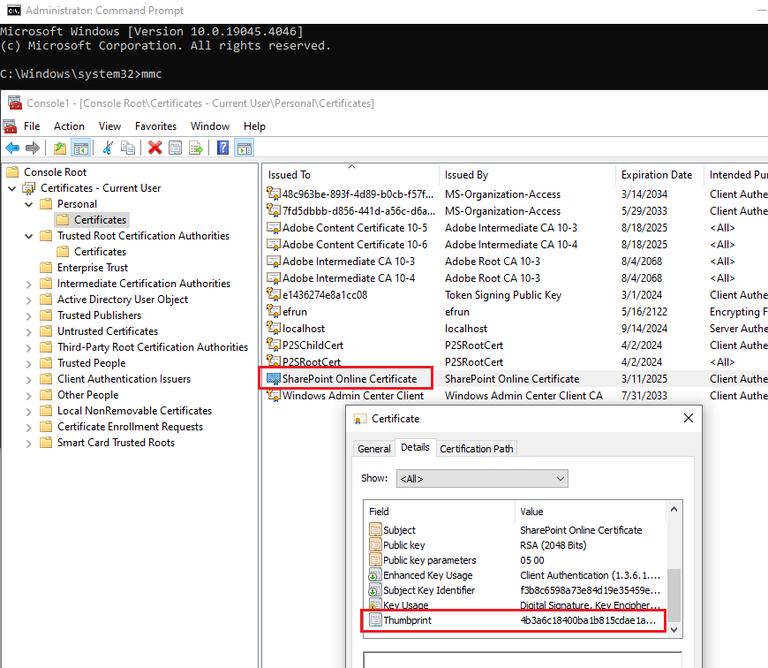

Figure

#### Create a new Azure AD application.

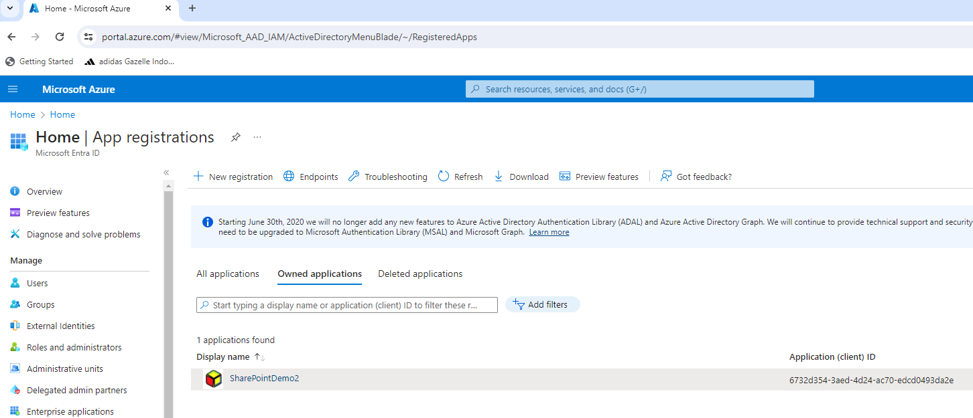

Figure

Make note of the Application ID and Tenant ID.

#### 

Figure

#### Configure Azure AD application’s permission.

Add the following permissions to the Azure AD application from above:

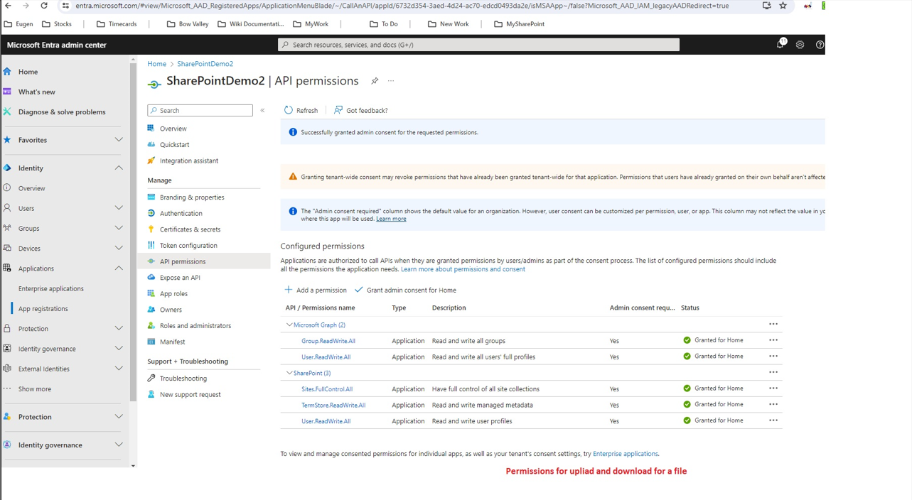

Figure

#### A screenshot of a computer Description automatically generatedImport the certificate under “Certificates & Secrets”.

Figure

#### Write the Azure Function Application to authenticate in SharePoint via the certificate.

The code is using:

* the Azure AD ClientID
* the Azure AD TenantID
* the SharePoint site URL and site name
* the client certificate,

to create an Authentication Provider.

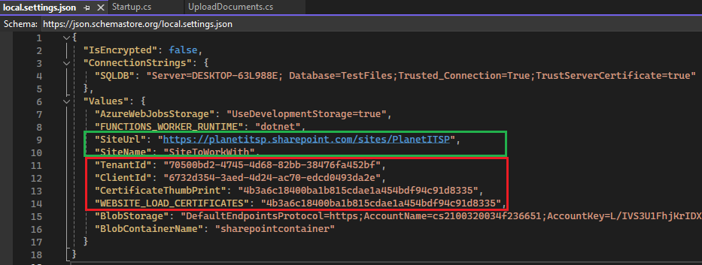The certificate can be loaded from the Local Machine store when running the function locally or from a configuration variable in the deployed Azure function.

Figure

**Note:** In the next steps, the function has been deployed in Azure with the name of “TestSPFiles” and configured as follows.

Figure

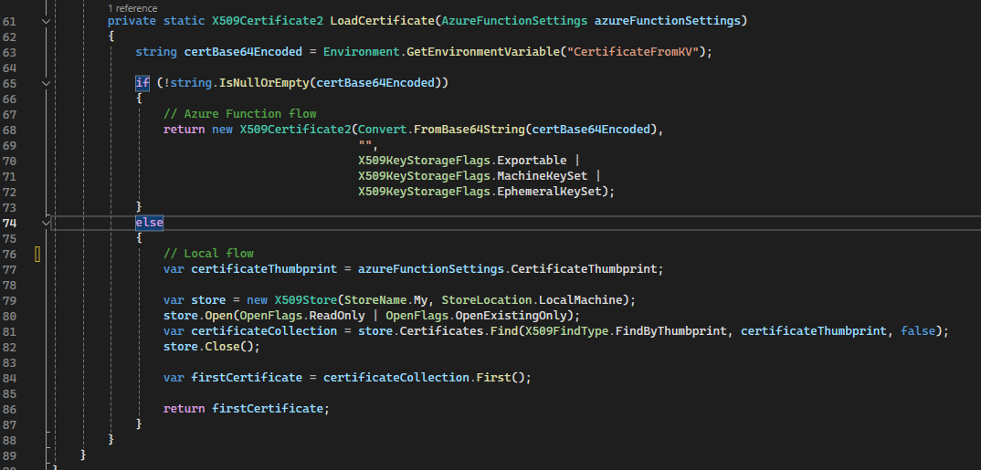

Figure

#### For the function app to have access to the Azure Key Vault, where the certificate is finally installed, the function app needs to use Managed Identity.

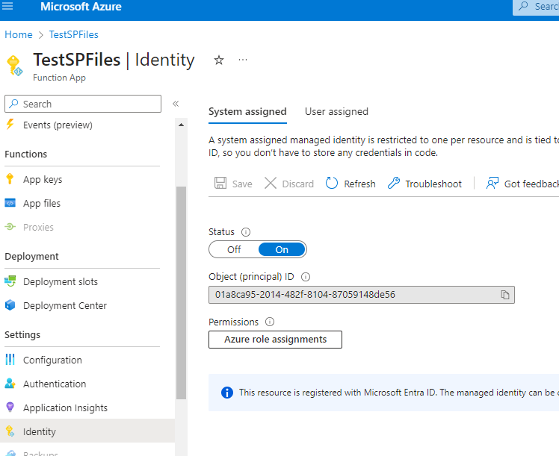

Figure

#### Managed identity with Azure Key Vault

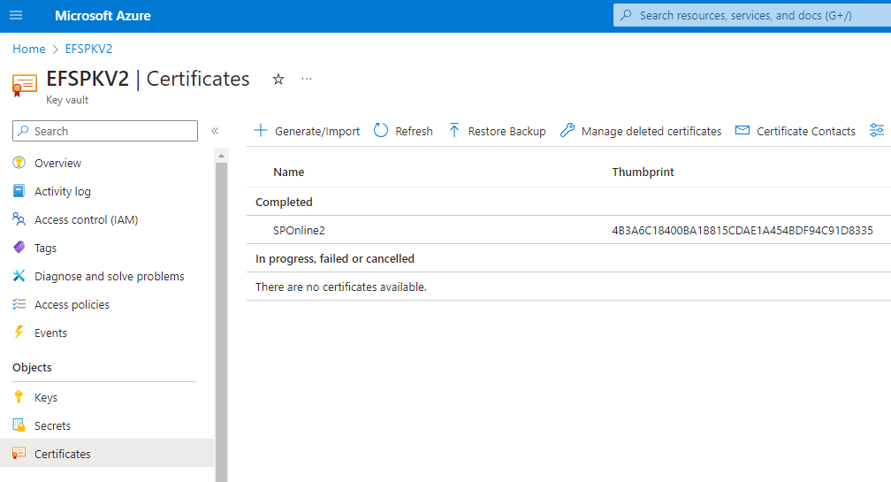Create an Azure Key Vault and import the certificate into it.

Figure

Create a new access policy as described below and select the Azure function app using the name (“TestSPFiles”):

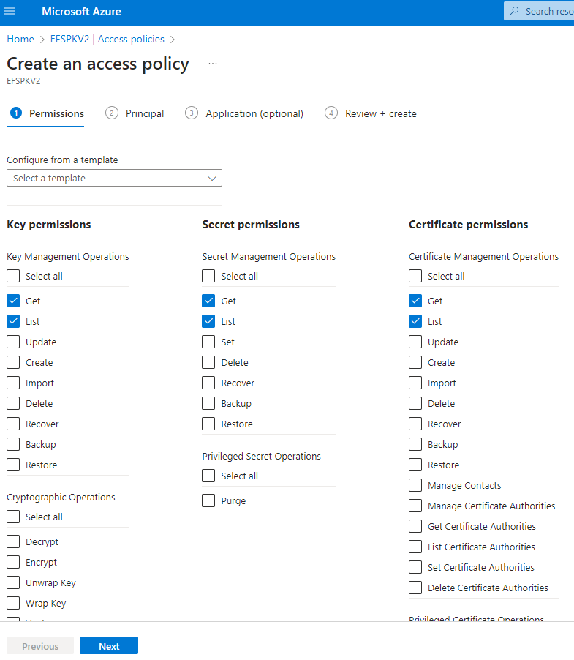

Figure

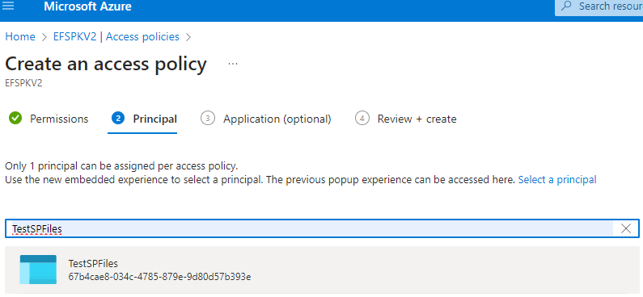Using the setup described above, the Azure function app has access to the Key Vault to load the certificate.

Figure

#### Web APIs functions

DownloadFileFromSharePoint

* Download a file from the SharePoint site’s folder named: “Shared Documents”.

UploadFileToSharePoint

* Upload a file to the SharePoint site’s folder named: “Shared Documents”.

DownloadFileFromBlob

* Download a file from a Blob Container named: “SharePointContainer”.

UploadFileToBlob

* Upload a file to a Blob Container named: “SharePointContainer”.

ReadFileFromBlobUploadToSharePoint

* Read a file from the Blob Container named: “SharePointContainer” and upload it to the SharePoint site’s folder named: “Shared Documents”.

ReadFileFromSQLUploadToSharePoint

* Read a file from a SQL Server database based on a blobID input paramater and upload it to the SharePoint site’s folder named: “Shared Documents”.

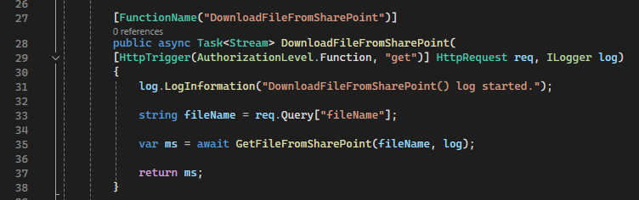

Figure

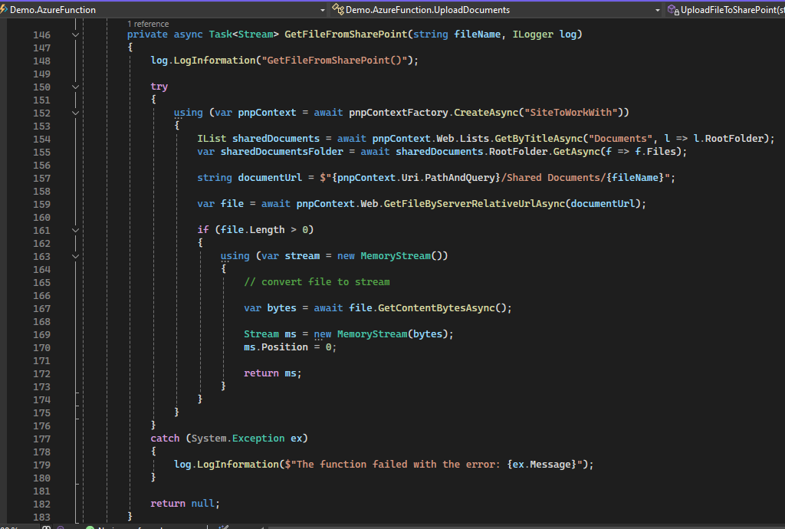

Figure

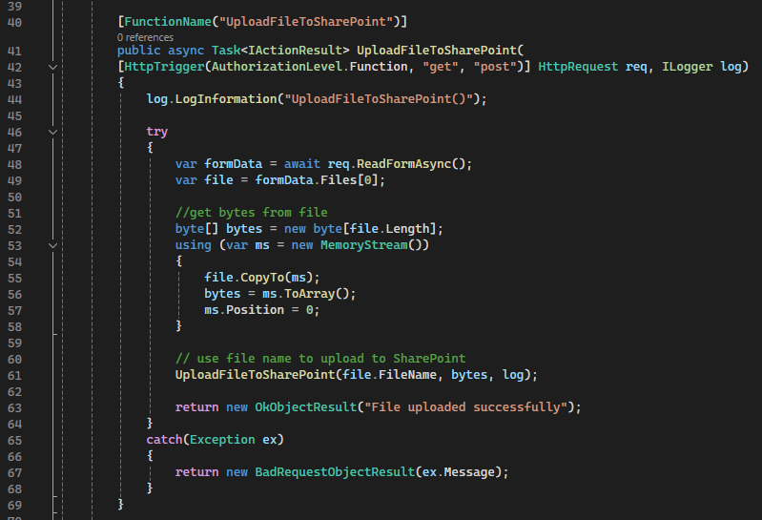

Figure

Figure

#### A screen shot of a computer code Description automatically generated Testing from Postman

Figure

Set up Postman and upload your certificate in the “Settings/Certificates” menu item (Figure 18):

Create a Get request to the following URL:

<https://testspfiles.azurewebsites.net/api/DownloadFileFromSharePoint?code=cnYaNZH_2Uxp_ApZIb7OjVeHcNTUKUCqXj5iYSx2vnfuAzFuQC3bHw==&fileName=UploadedG2.jpg>

and click on “Send and Download” button.

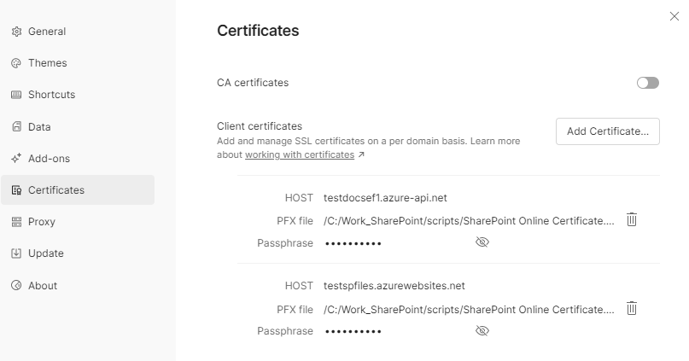

Figure

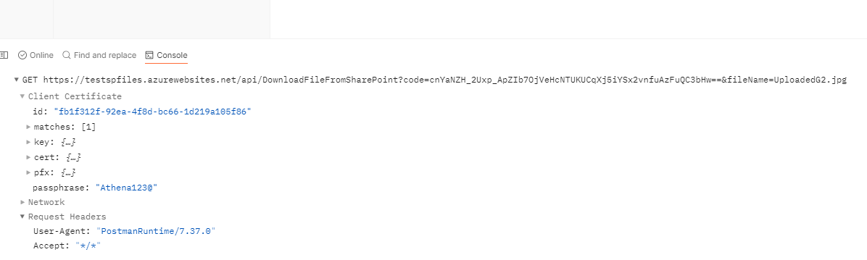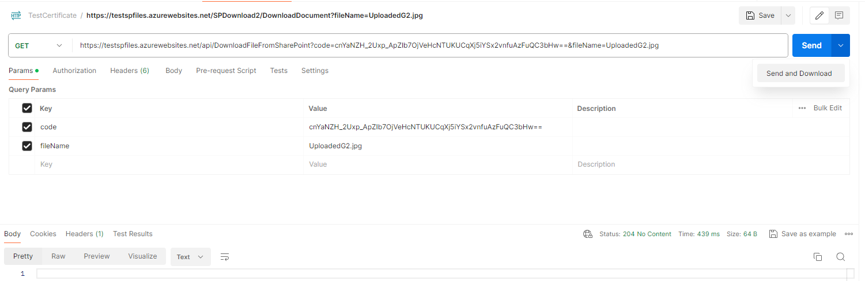You can see the certificate being sent in the request and the file being downloaded.

Figure

Figure

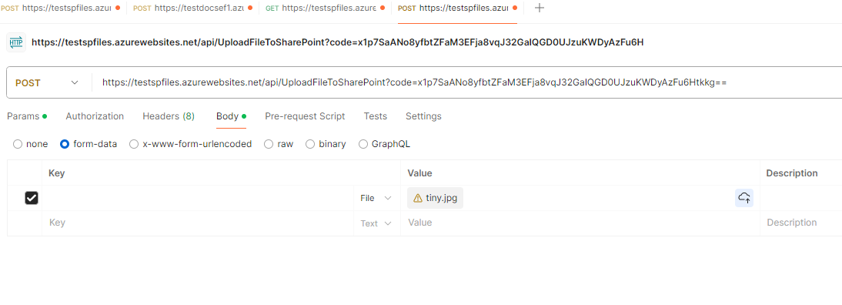Upload a file request is displayed below:

Figure

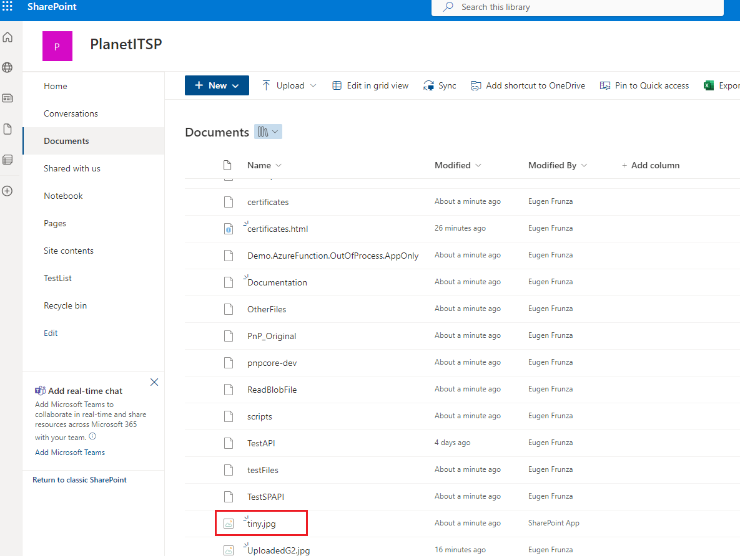

Figure

#### API Management setup

Create an API Management resource.

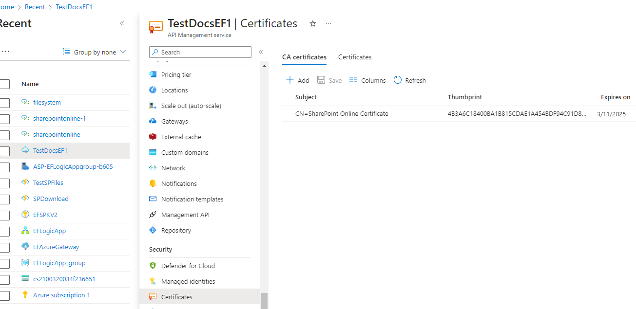Upload the certificate file:

Figure

Load the APIs from the function app:

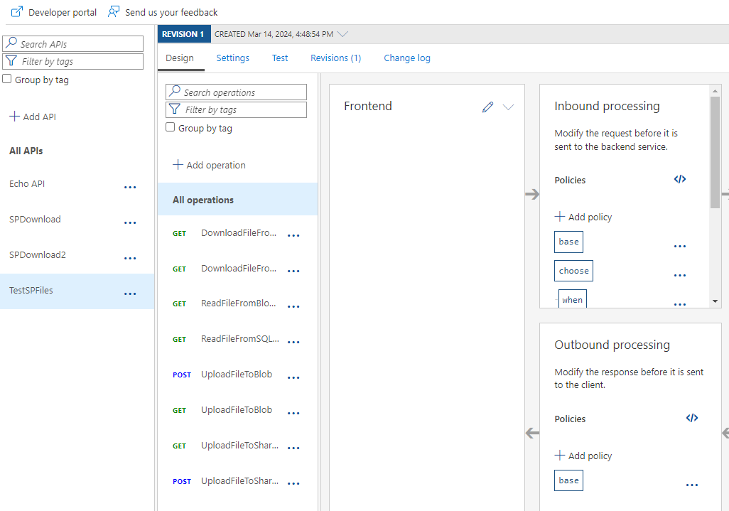

Figure

Apply the following policy to allow only calls passing in the certificate with the expected thumbprint:

<policies>

    <inbound>

        <base />

        <choose>

            <when condition="@(context.Request.Certificate == null)">

                <return-response>

                    <set-status code="403" reason="@(context.Request.Certificate.Thumbprint)" />

                </return-response>

            </when>

            <when condition="@(!context.Request.Certificate.Verify())">

                <return-response>

                    <set-status code="403" reason="Certificate not validated" />

                </return-response>

            </when>

            <when condition="@(!context.Deployment.Certificates.Any(c => c.Value.Thumbprint == context.Request.Certificate.Thumbprint))">

                <return-response>

                    <set-status code="403" reason="@(context.Request.Certificate.Thumbprint)" />

                </return-response>

            </when>

        </choose>

    </inbound>

    <backend>

        <base />

    </backend>

    <outbound>

        <base />

    </outbound>

    <on-error>

        <set-header name="ErrorSource" exists-action="override">

            <value>@(context.Request.Certificate.Thumbprint)</value>

        </set-header>

        <set-header name="ErrorReason" exists-action="override">

            <value>@(context.Request.Certificate.Thumbprint)</value>

        </set-header>

        <set-header name="ErrorMessage" exists-action="override">

            <value>@(context.Request.Certificate.Thumbprint)</value>

        </set-header>

        <base />

    </on-error>

</policies>

Make a note of the “Ocp-Apim-Subscription-key” that will be used to invoke the APIs:

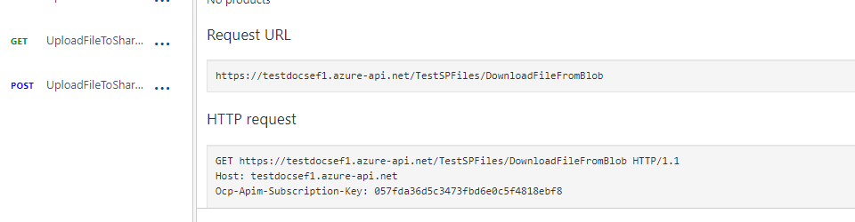

Figure

#### Testing from Postman

Test the APIs in the same manner as before but passing in the ocp subscription key:

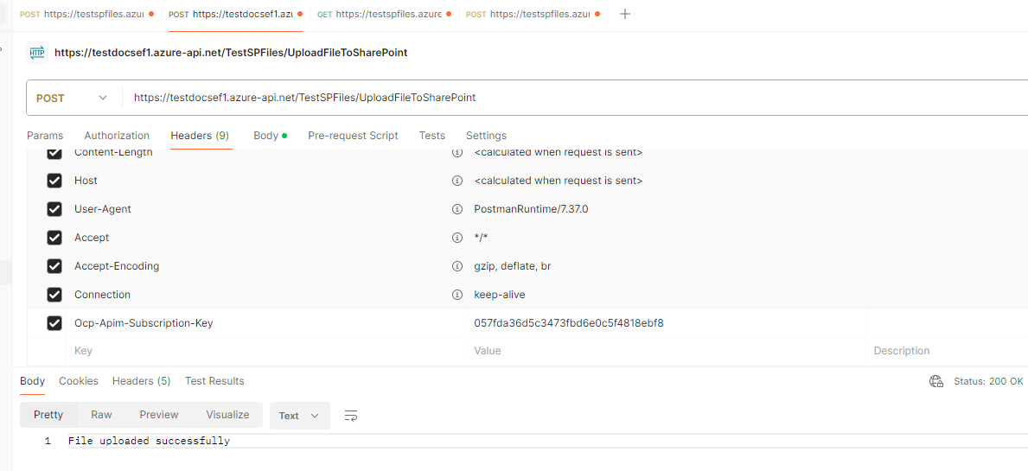

Figure

#### Console Application

The .NET Console App perform the following operations:

* UploadFileToSharePoint
* DownloadFileFromSharePoint
* CreateFileToFileSystem
* UploadFileToBlob
* DownloadFileFromBlob
* CreateFileToFileSystem
* UploadFileToSQL
* RetrieveFileFromSQL
* CreateFileToFileSystem

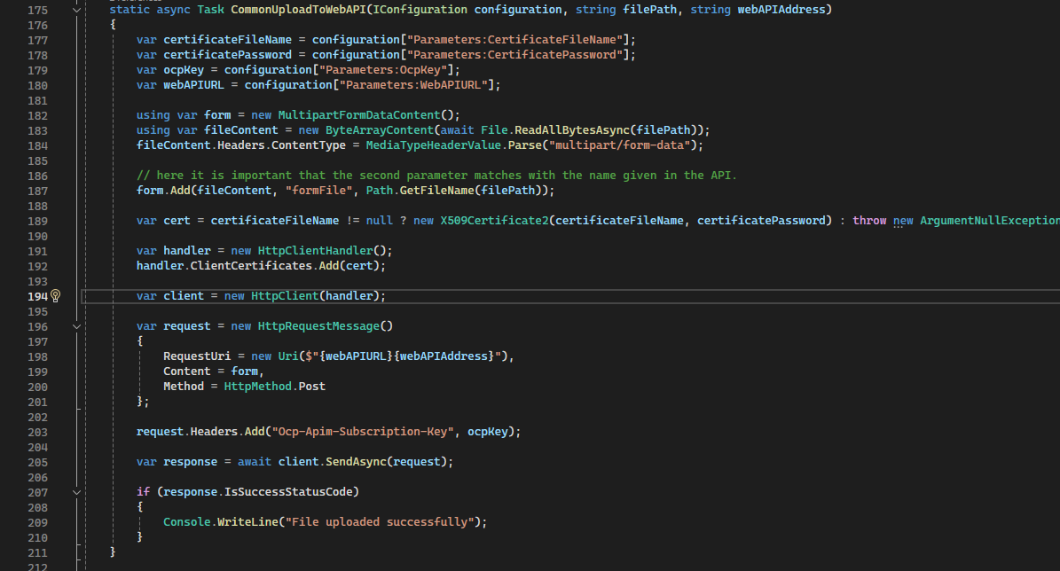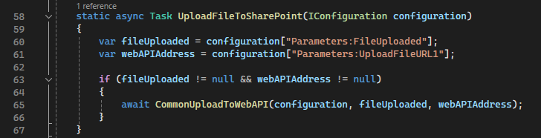

Figure

Figure

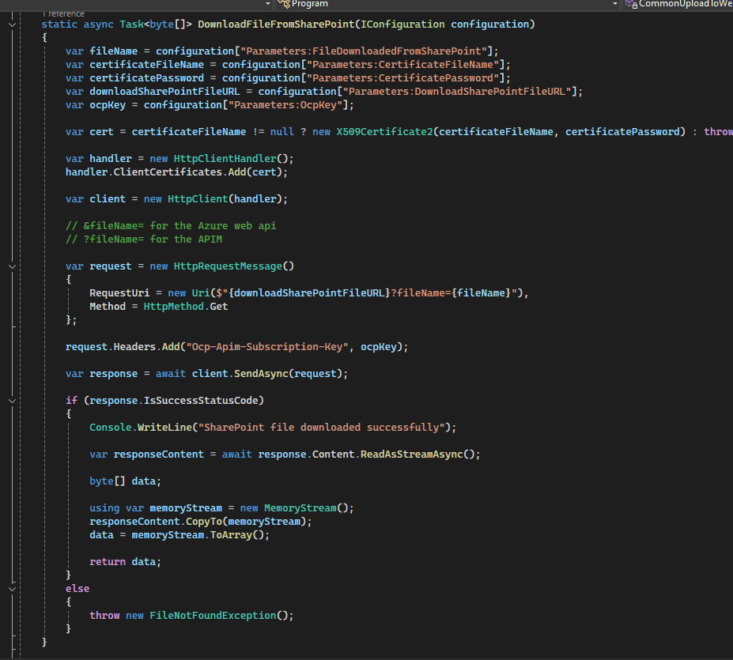

Figure

The code is passing the certificate and the ocp subscription key when making the calls to the web APIs from the API Management resource.

#### Working with certificates

Follow the steps from this document: [Extracting Certificate.crt and PrivateKey.key from a Certificate.pfx File](https://helpcenter.gsx.com/hc/en-us/articles/115015887447-Extracting-Certificate-crt-and-PrivateKey-key-from-a-Certificate-pfx-File) if you need to generate the certificate files with the extension “crt” and “key”. These files may be used in some instances for testing i.e. they can be loaded by Postman as well.

#### Price

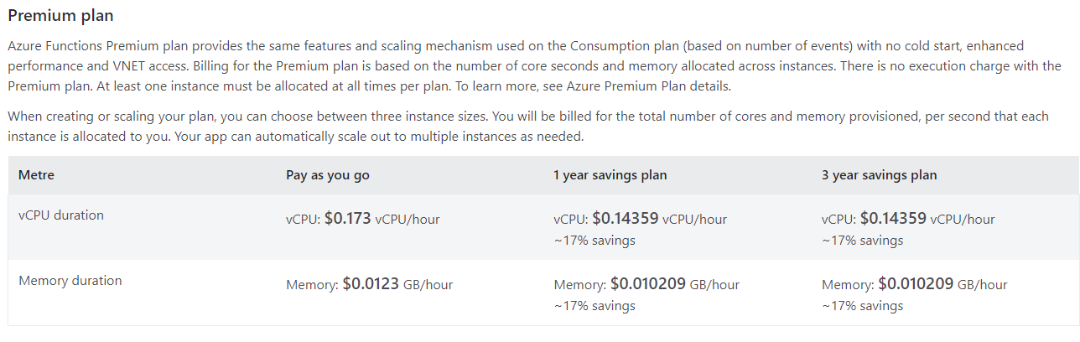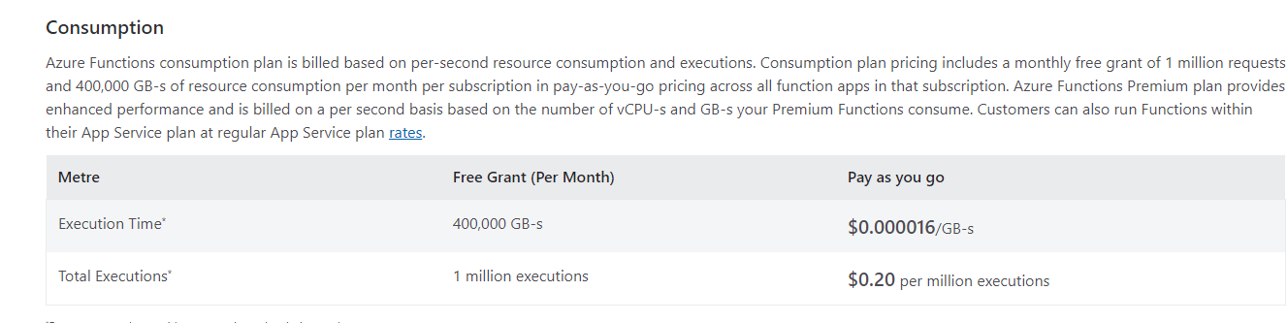Azure Functions

Figure

Figure

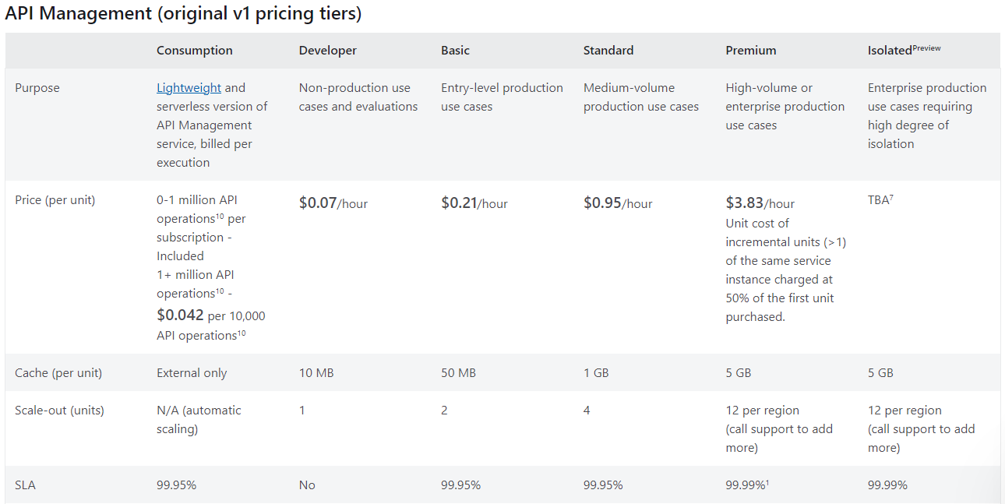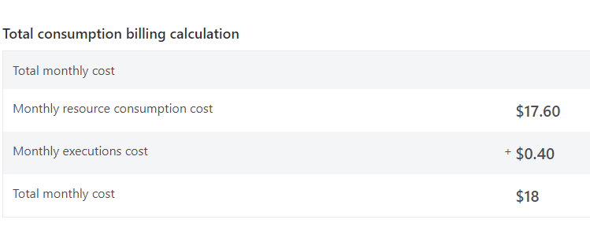

Figure

Figure

Figure

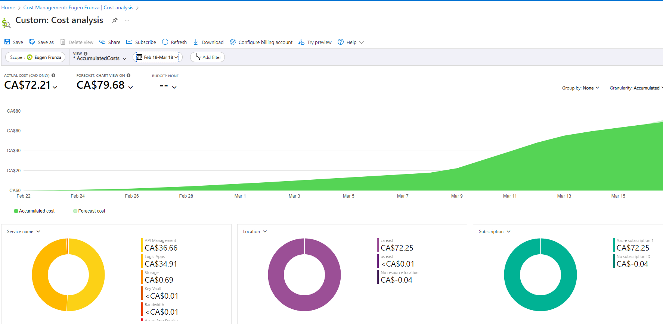

# A screenshot of a computer Description automatically generatedRecommendation: Monitor the Production environment resources execution for a given function / APIM / Resource Group for a period of time to estimate the real cost.

Figure

# Write the POC using Graph API

* 1. Write the functions using Graph API

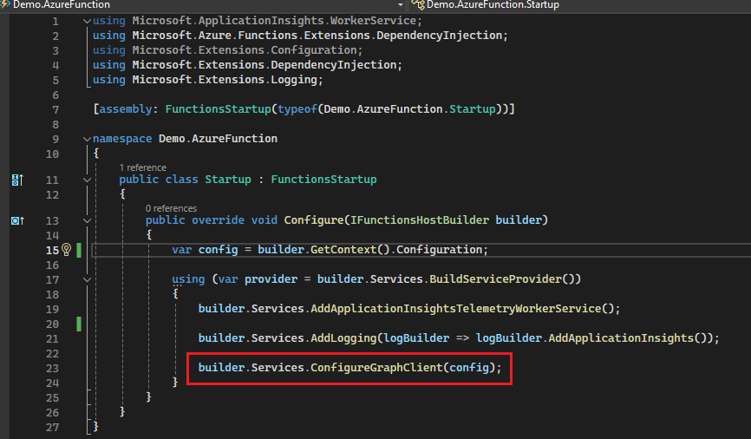Create the Graph client via the dependency injection:

Figure

Create a Graph Provider to configure the graph client via the certificate:

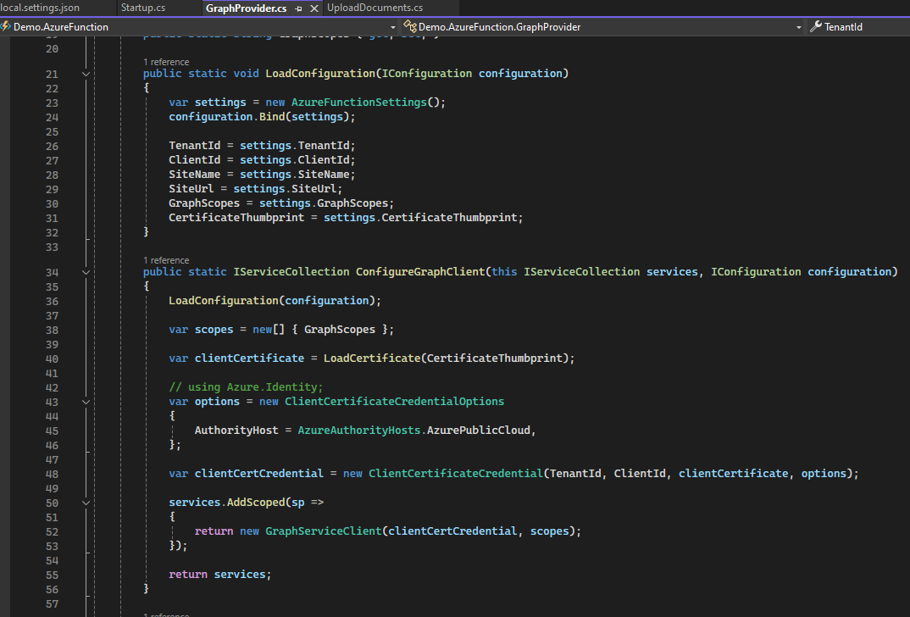

Figure

Use the graph client inside the functions which uploads and downloads files from SharePoint:

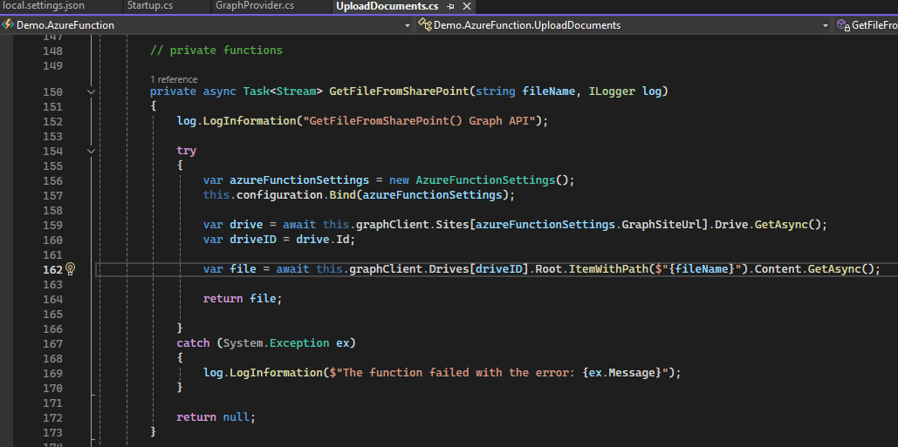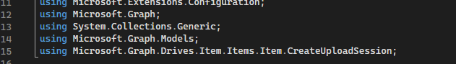

Figure

Figure

Note: The function uploads large files, but I must test it out and see the sizes accepted.

Figure

* 1. 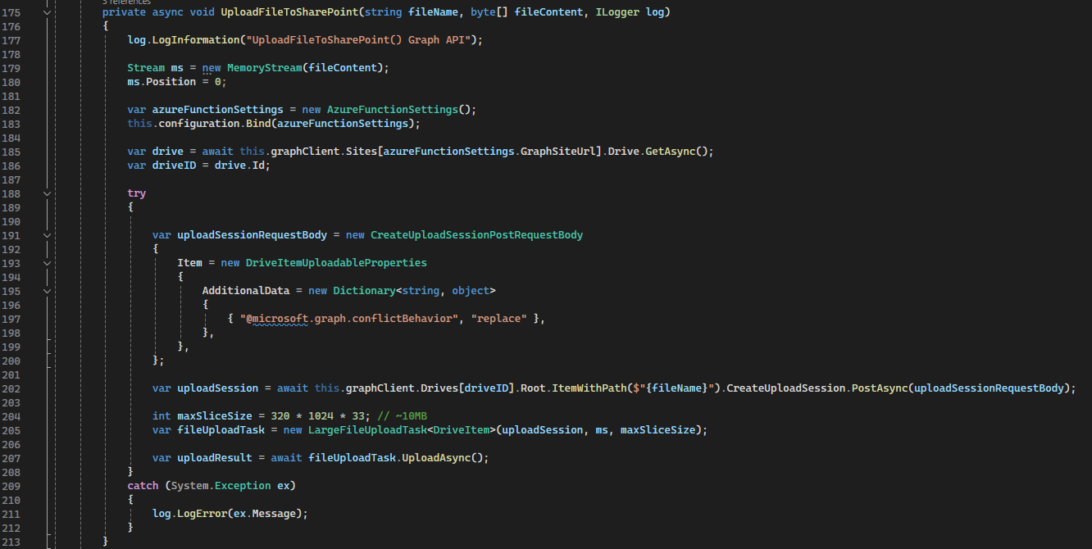Deploy the functions in APIM and test them using Postman.

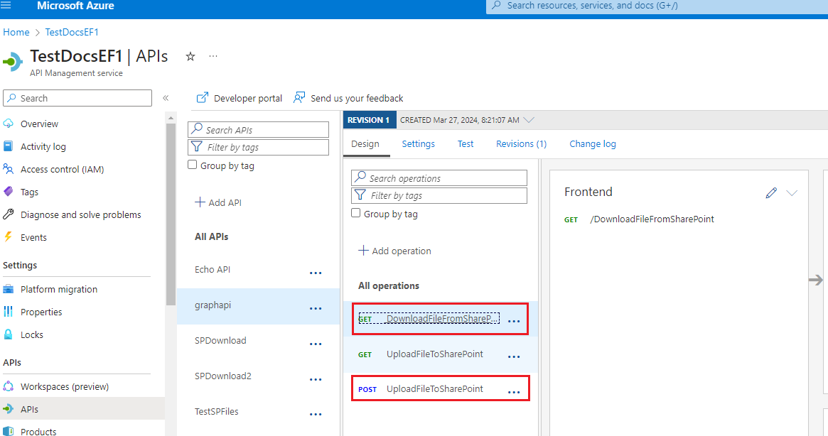

Figure

Same tests as in 2.1.2.1 but using a different API address:

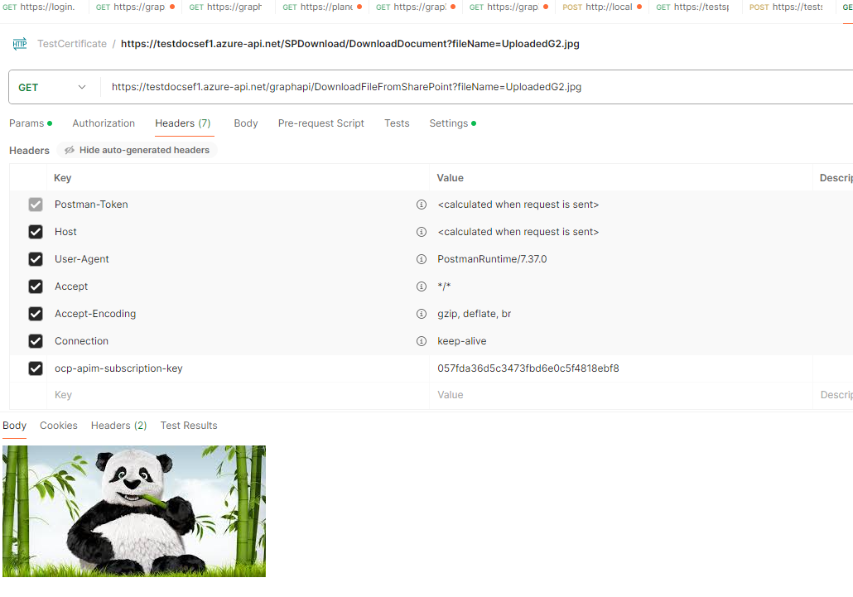

Figure

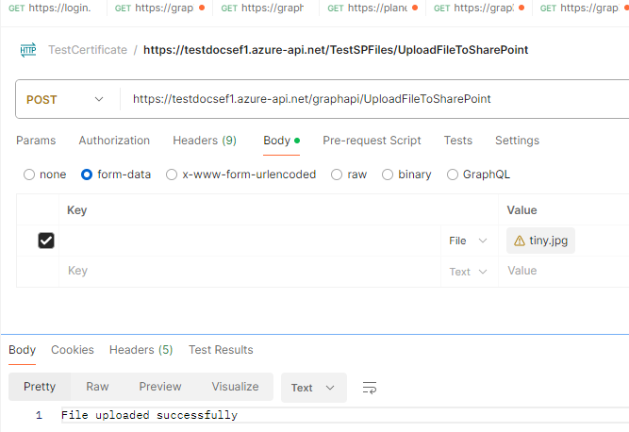

Figure

* 1. Modify the console app and test the new APIs from the console app.

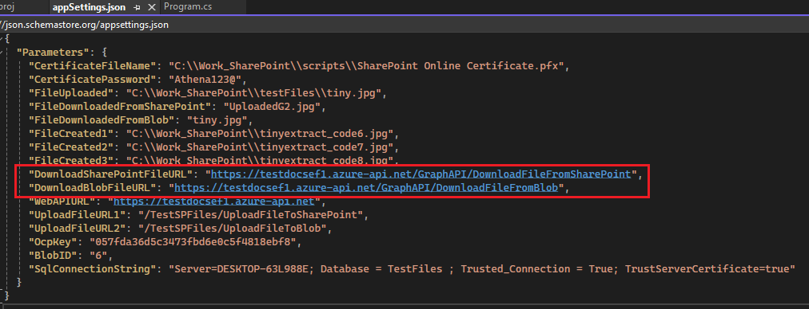The only change is to the APIs links references inside the appsettings.json

Figure

1. Versioning
   1. How to use Graph API documentation and APIs with Postman

Go to the Microsoft Graph REST API v1.0 documentation’s site:

https://learn.microsoft.com/en-us/graph/api/overview?view=graph-rest-1.0&WT.mc_id=m365-30352-cxa

For each operation you need you will find a documentation page.

Look at the HTTP requests.

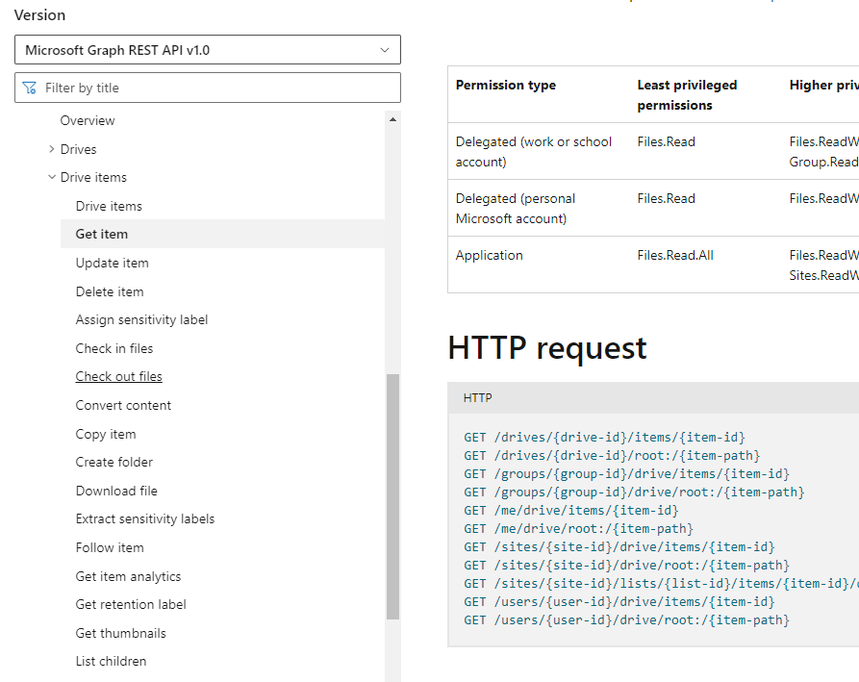

Figure

Make the corresponding call in Postman and investigate the result.

As an example, get the drives from the SharePoint sites:

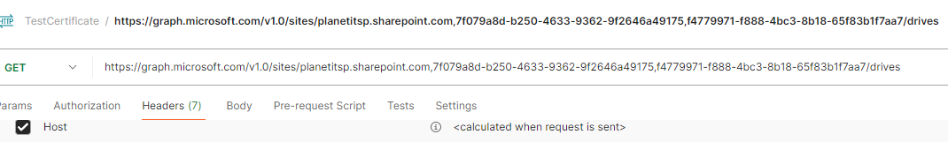

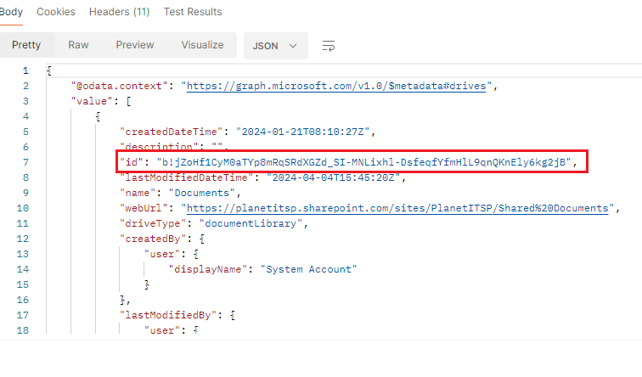Make a note of the drive id from the given result:

Figure

Look for your item in the SharePoint site:

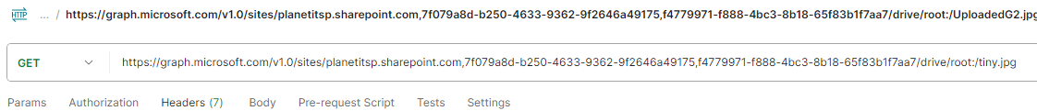Make a note of the item id from the result set:

Figure

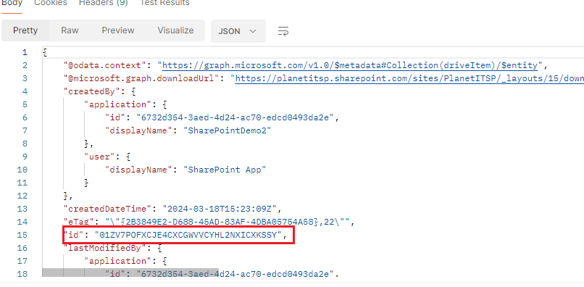

Figure

Use the ids from above and retrieve the versions for this file:

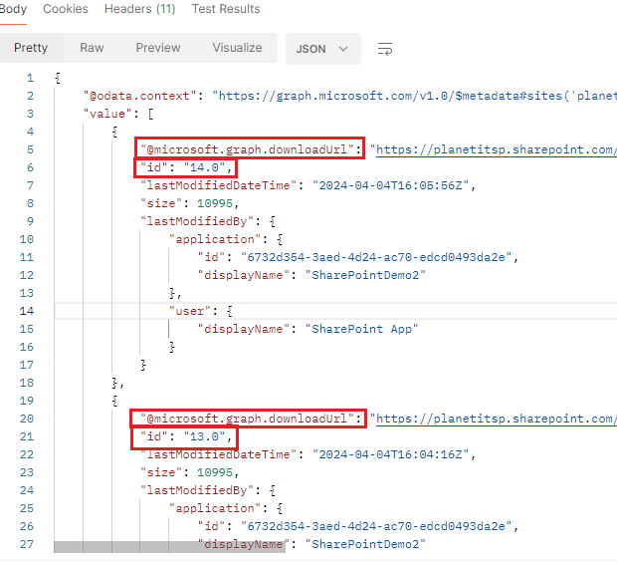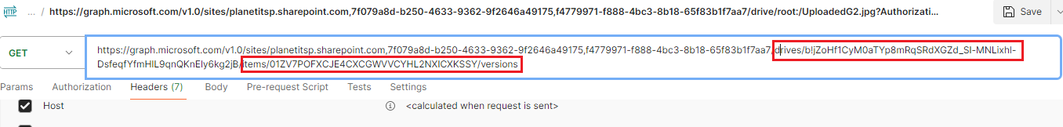You can see the versions in the result set.

Each file’s version has a downloaded URL. You can download the file’s version using this url.

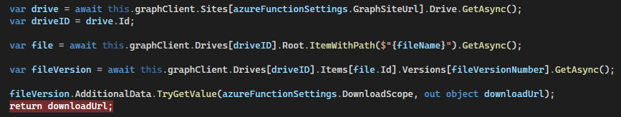Implement the code in a similar manner, passing into the Graph APIs the drive id, the item id, the file version number retrieve the download URL:

Figure

* 1. 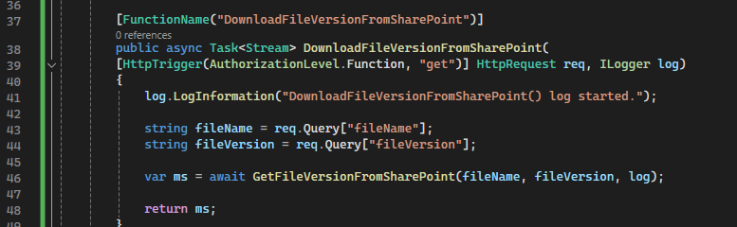Download a file version:

Figure

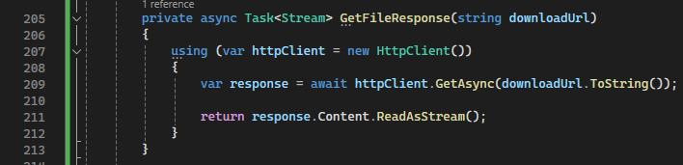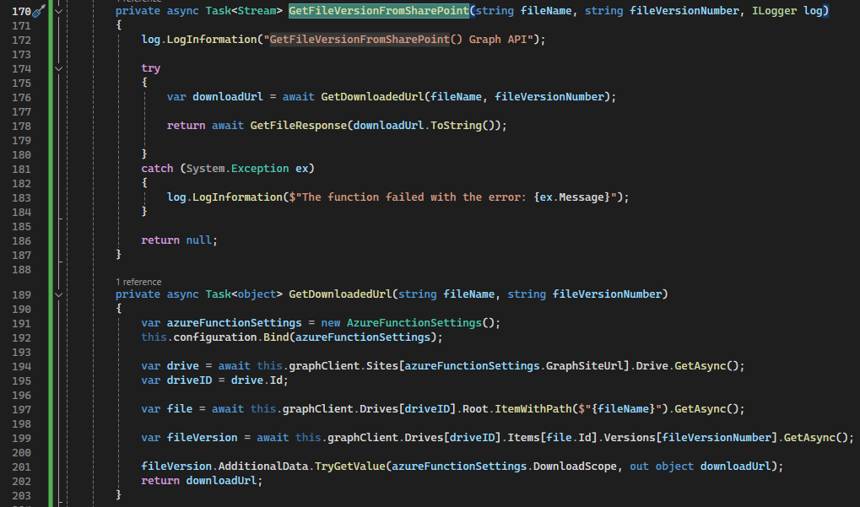

Figure

Figure

* 1. 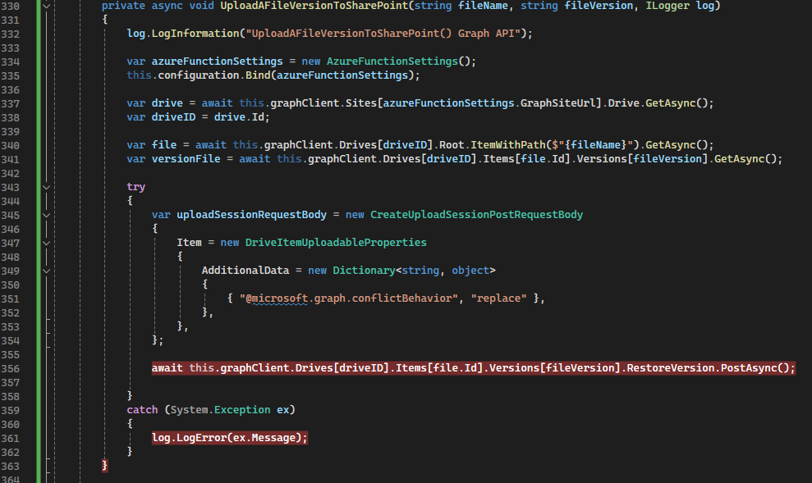Upload a file version.

Figure

* 1. 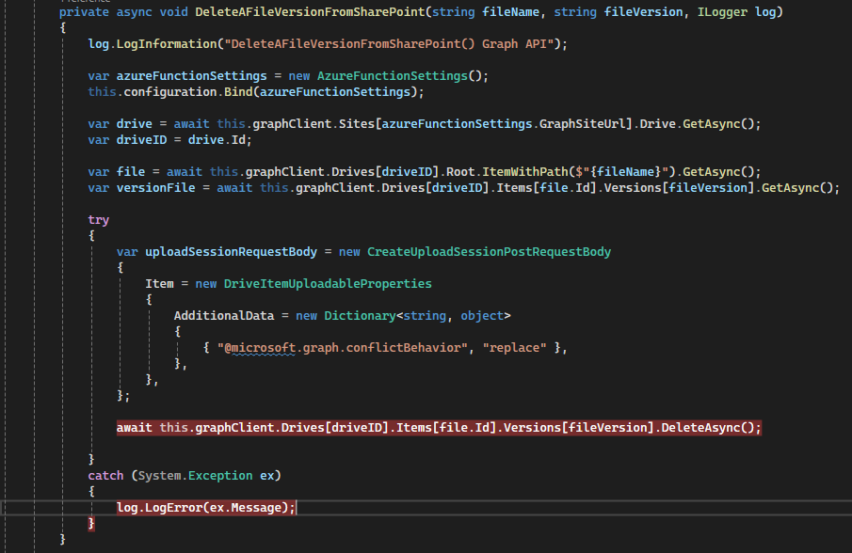Delete a file version.

Figure

* 1. An example of downloading, restoring, and deleting a file version is presented below:

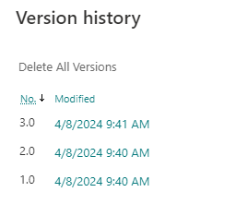Create a text file and add a text inside it containing the version number.

Figure

Retrieve the first version for this file:

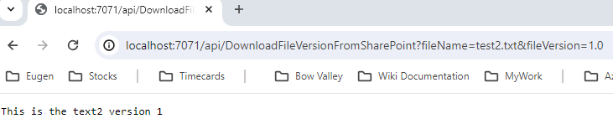

Figure

Upload the first version of the file to SharePoint:

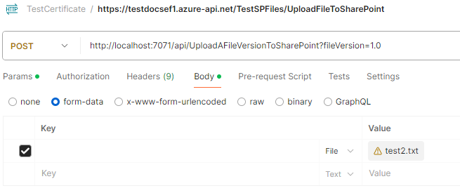Once the new version has been uploaded, it became the most recent version, version 4:

Figure

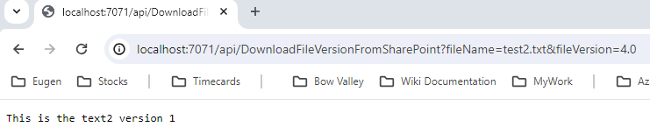

Figure

Now, delete the file version number 2:

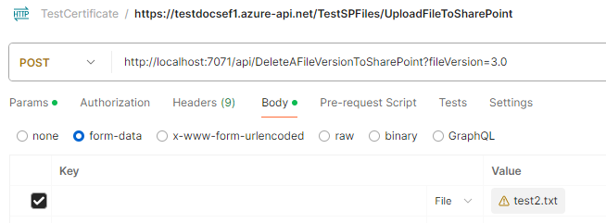

Figure

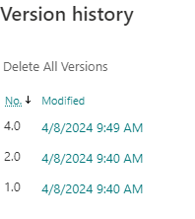The result is displayed below:

Figure

1. Metadata

5.1 How to use metadata.

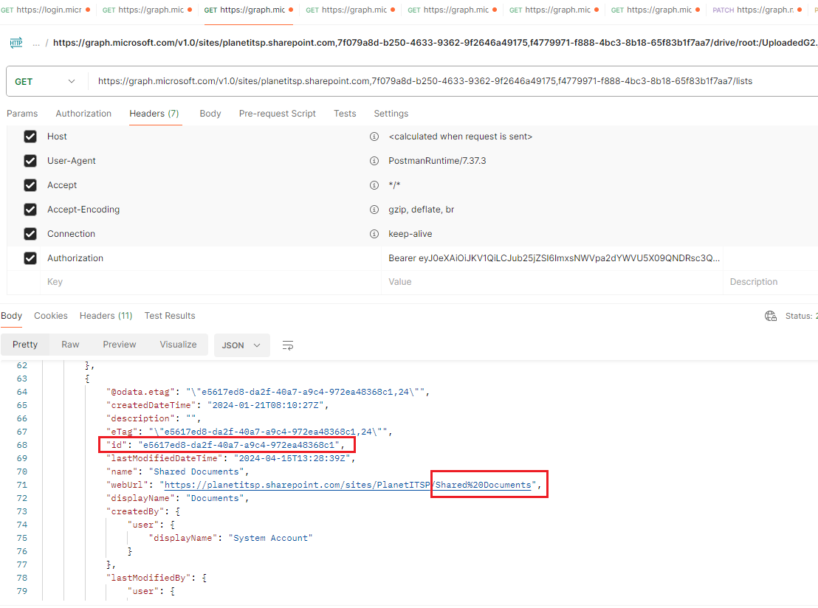Get the id for the Shared Documents folder:

Figure

Get the items from the Shared Documents folder and look for the id for the item you are interested in:

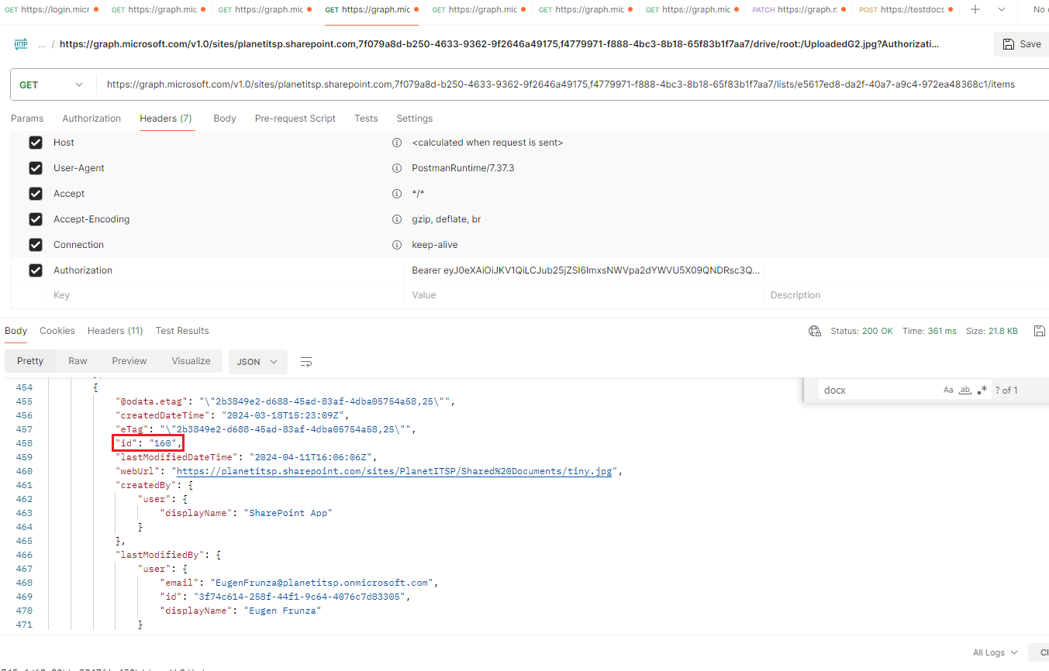

Figure

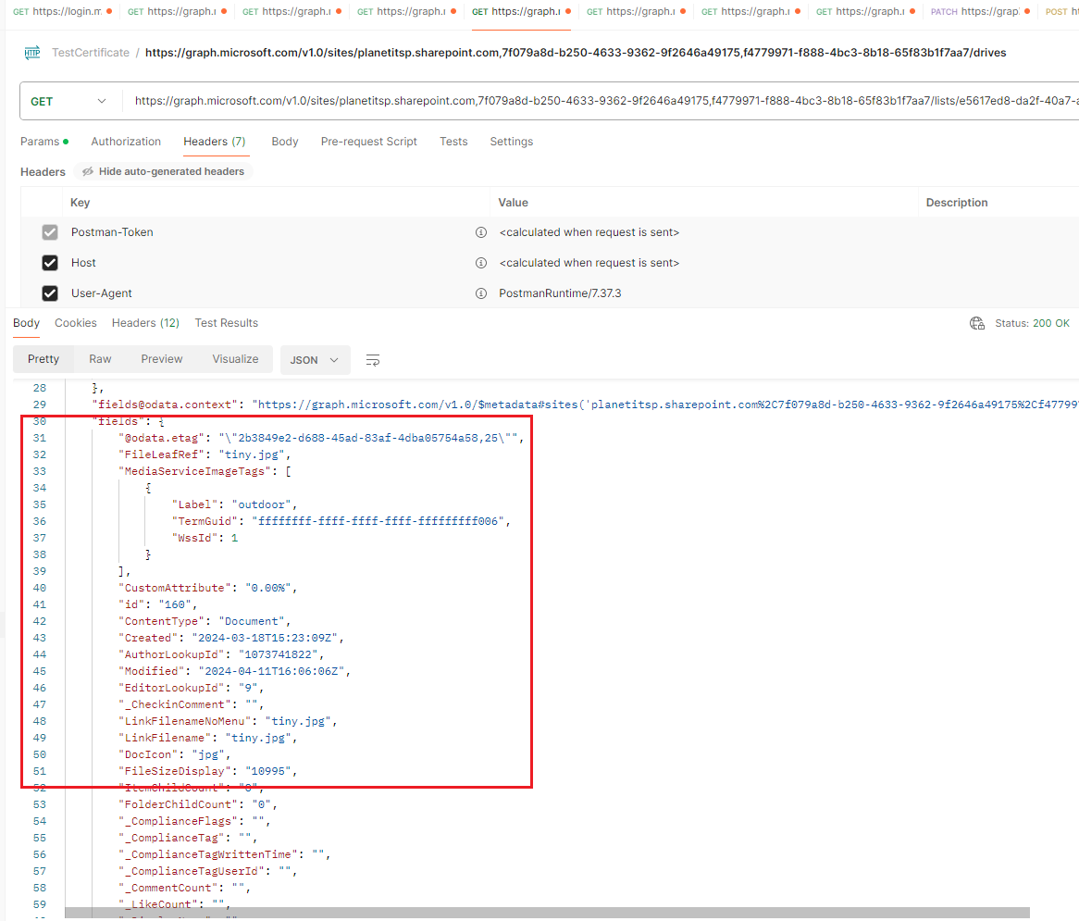Get the metadata fields for this item:

Figure

URL is:

<https://graph.microsoft.com/v1.0/sites/planetitsp.sharepoint.com,7f079a8d-b250-4633-9362-9f2646a49175,f4779971-f888-4bc3-8b18-65f83b1f7aa7/lists/e5617ed8-da2f-40a7-a9c4-972ea48368c1/items/160?$expand=fields>

Select a particular attribute named: “CustomAttribute”:

<https://graph.microsoft.com/v1.0/sites/planetitsp.sharepoint.com,7f079a8d-b250-4633-9362-9f2646a49175,f4779971-f888-4bc3-8b18-65f83b1f7aa7/lists/e5617ed8-da2f-40a7-a9c4-972ea48368c1/items/160?$expand=fields($select=CustomAttribute)>

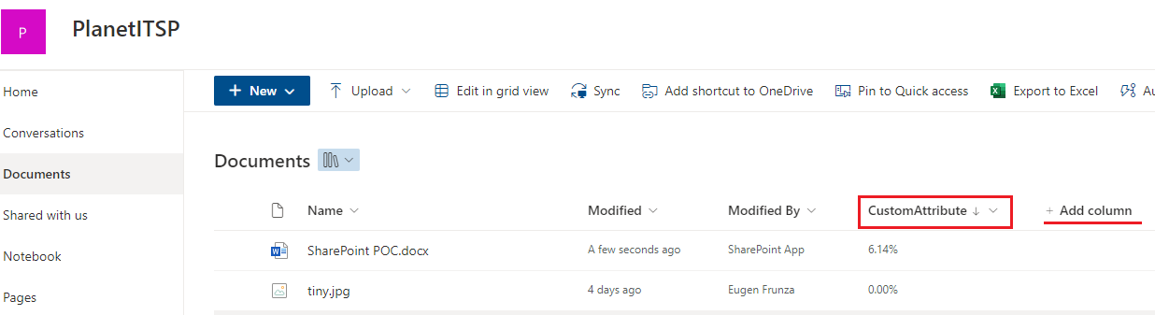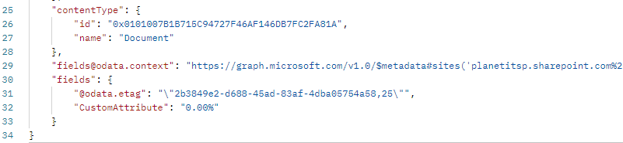You can create new attributes (columns) in SharePoint:

Figure

Figure

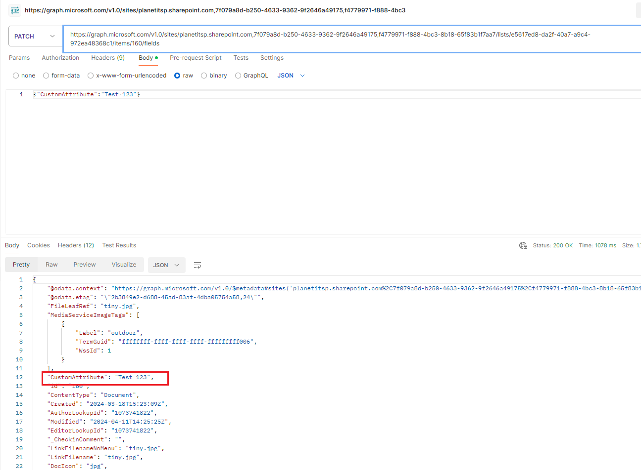Update the custom attribute:

Figure

4.2 Function to update the custom attribute.

Figure

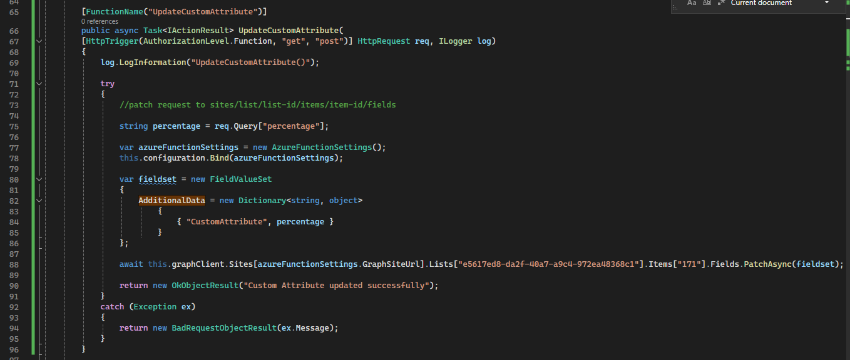4.3 Determine the degree of change for a file.

Use libraries to read the content of a file to text: Aspose.Word, Aspose.Excel. (Aspose.PDF?)

Use a library to compare the content and determine the deleted and inserted words: DiffMatchPatch.

Implement an algorithm to determine the number of words changed.

You can implement a business rule as such: if the changes are more than 10% create a new file or otherwise create a new version.

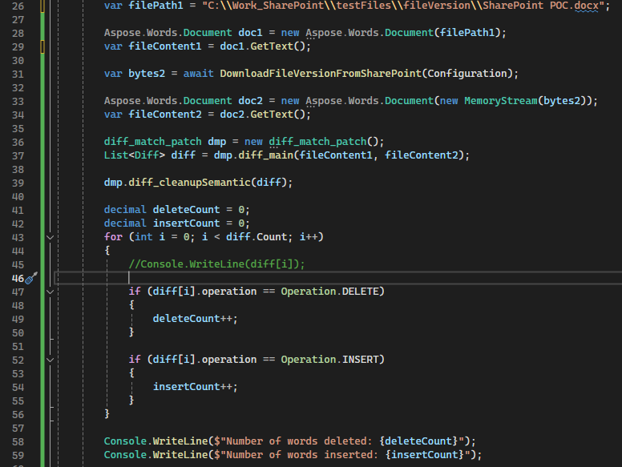

Figure

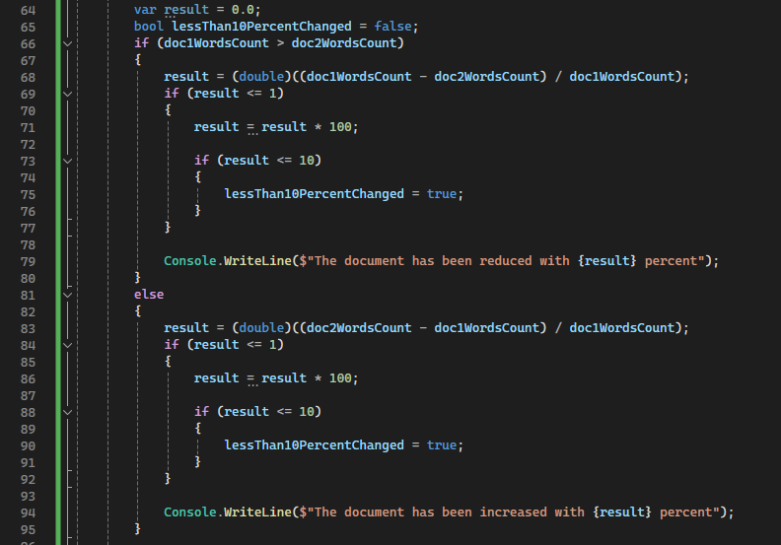

Figure

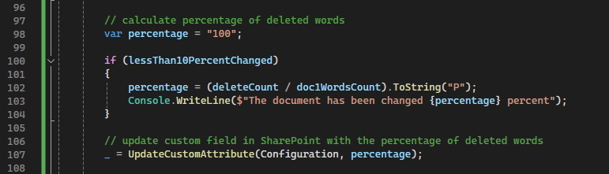I have replaced a few words in the file and uploaded a new version: the “CustomAttribute” has been updated to 6.14 % which shows the degree of change in the last file uploaded versus the previous version.

Figure

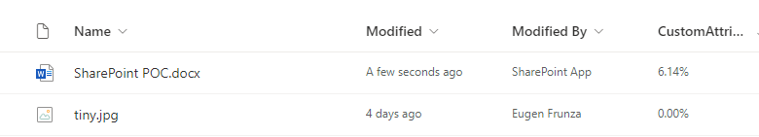I replaced the file with a completed different file’s content and uploaded it to SharePoint.

Figure

This time the “CustomAttribute” has been set to 100% - which should be the indication for a completely new file.

# Deployment scripts

* 1. 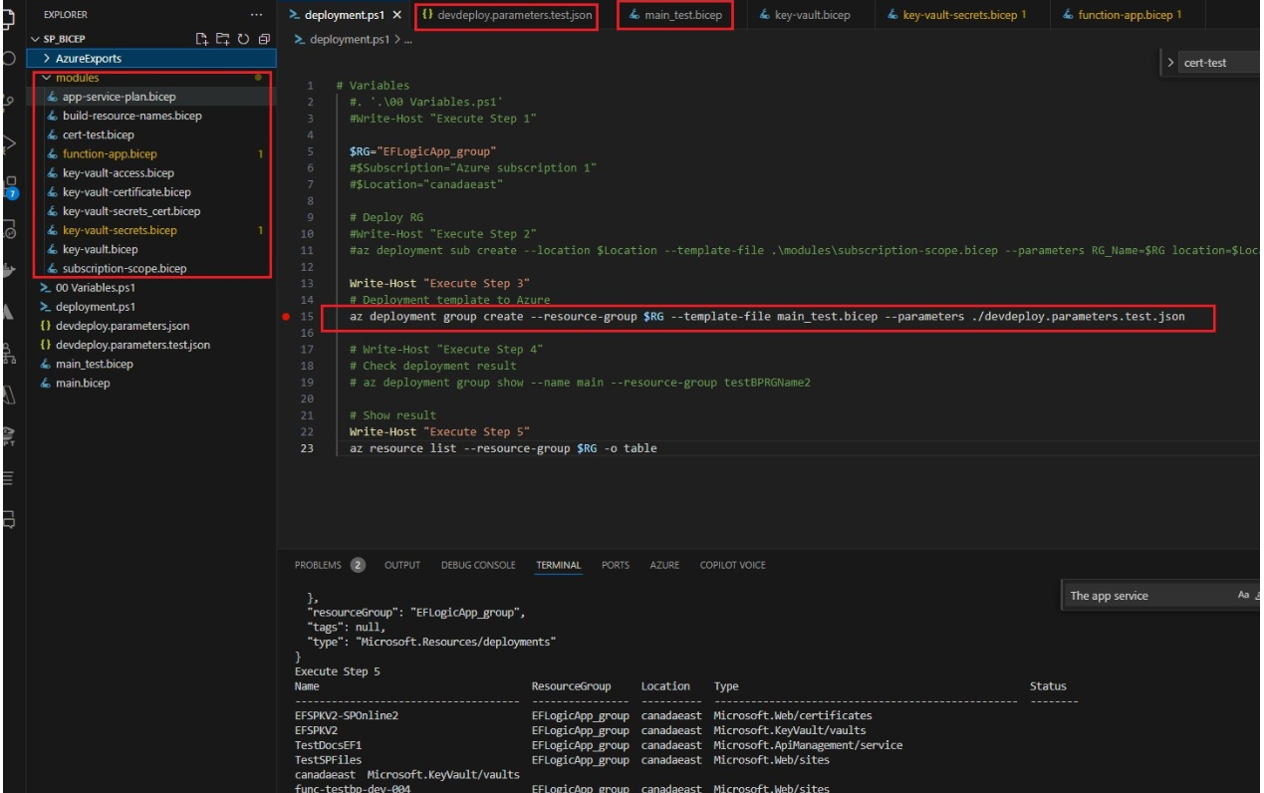Bicep scripts

Figure

To test the bicep scripts, you can use a PowerShell script that loads some parameters from a configuration file.

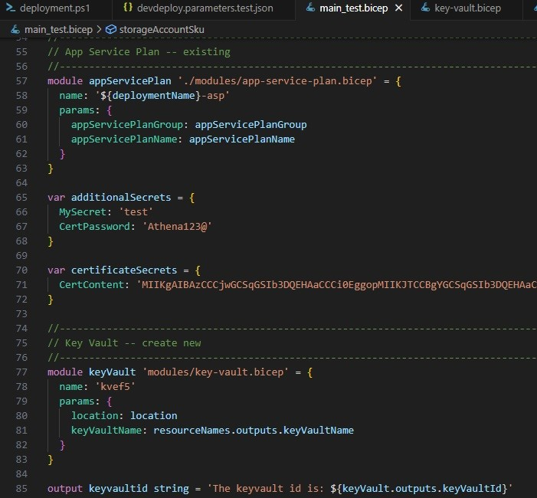Some Azure resources can be re-used (subscription, resource group, location, etc.) while others are newly created: storage account, key vault, function app, adding function app permissions to the key vault secrets, etc.

Figure

I have used a few modules for each resource to allow for reusability.

As an observation, adding the certificate into the key vault gives errors and after researching online articles on the subject it seems this Bicep functionality is not yet available.

As a workaround, I stored the certificate content and secret into 2 key vault secrets and modified the Azure function to read them from there.

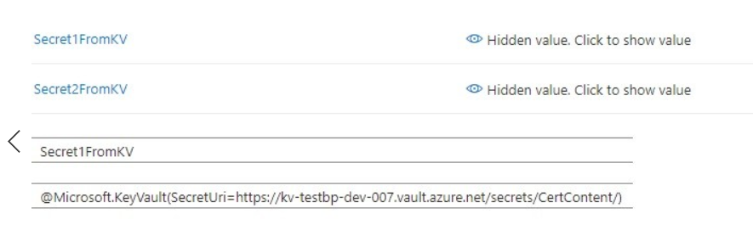You can add these 2 secrets into the Azure function configuration parameters with a similar binding as you have seen previously with the certificate:

Figure

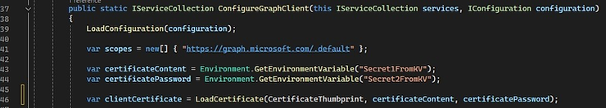

Figure

* 1. Deployment pipeline scripts

I have integrated the bicep script into the deployment pipeline and created a JSON file out of it using the Bicep CLI.

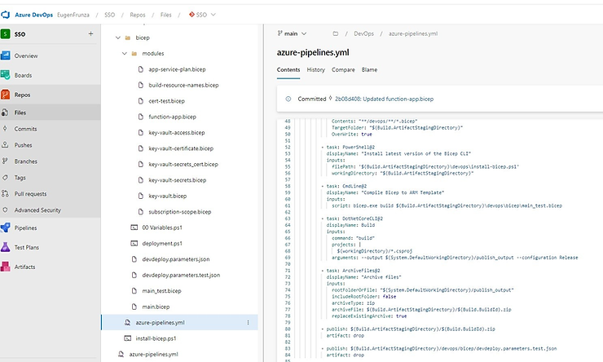

Figure

The deployment pipeline contains 2 tasks:

* an ARM template deployment task and
* 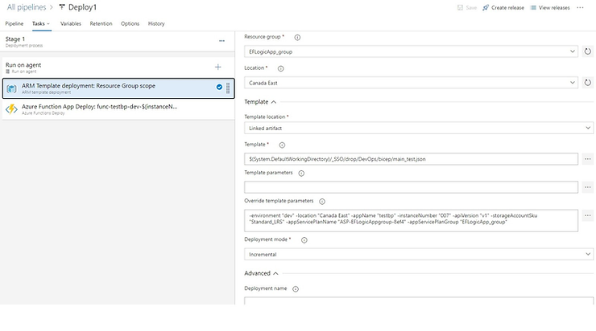a function app deployment task that adds the function app build on top of the created resources.

Figure

As a second workaround, make note that the deployment parameters are created under the Variables tab and not imported from the configuration file.

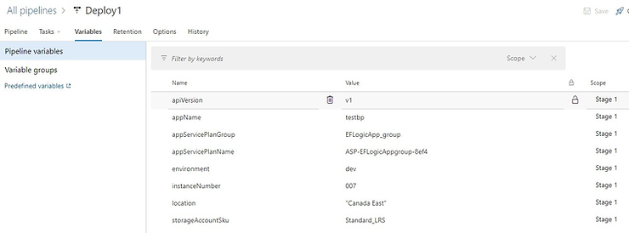

Figure

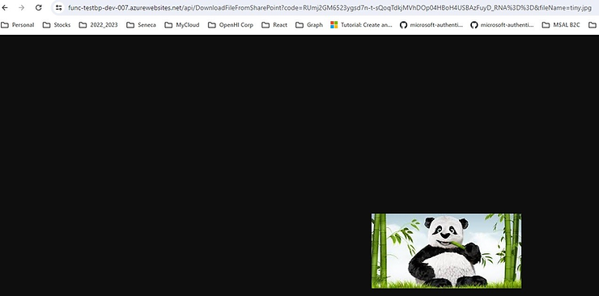After all the build and deployment pipeline completes successfully you can download our image from SharePoint using the deployed resources.

Figure

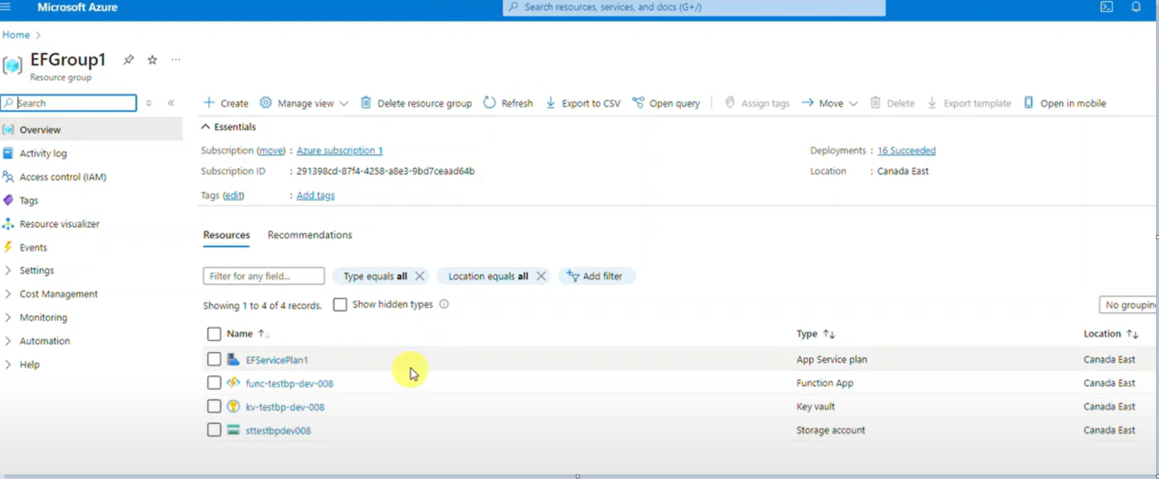The deployed resources allow for the functions to be called.

Figure

However, an extra step is required to add the functions into APIM.

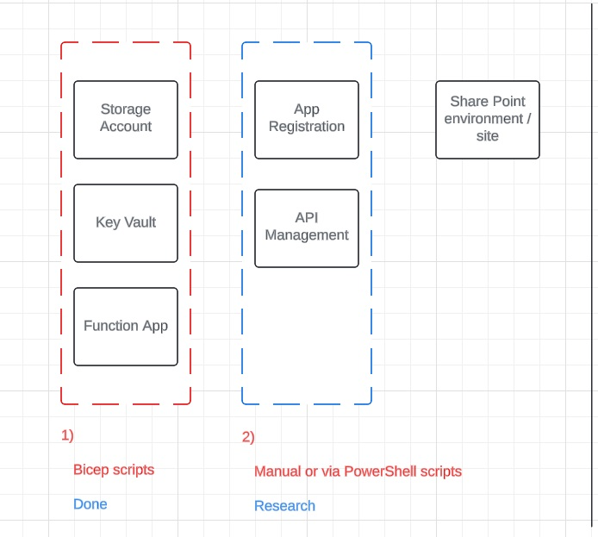

Figure

# A diagram of a software application Description automatically generatedAccess restrictions

Figure

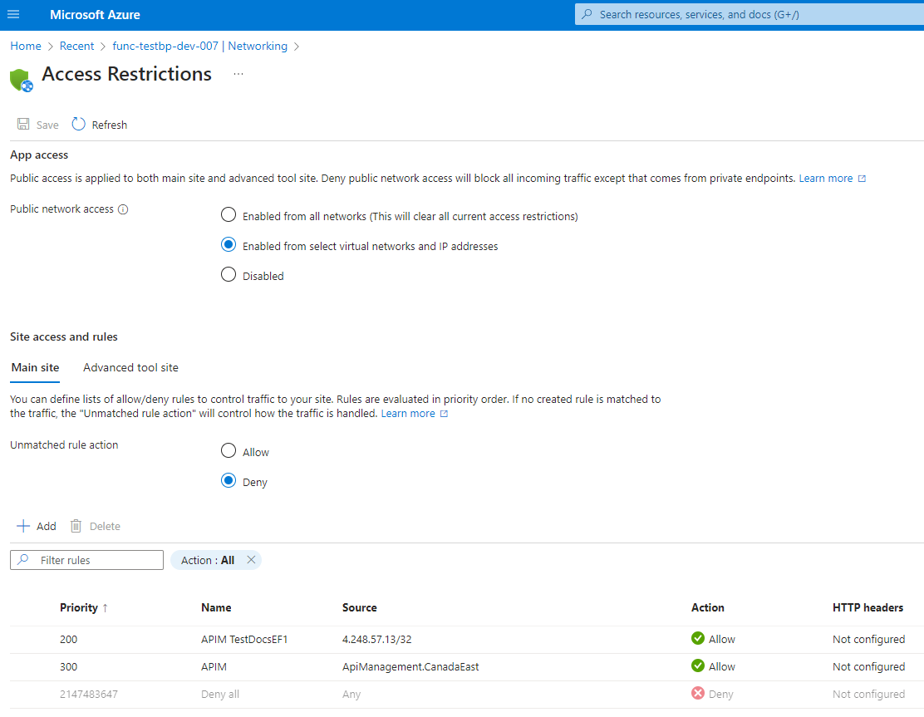

Figure

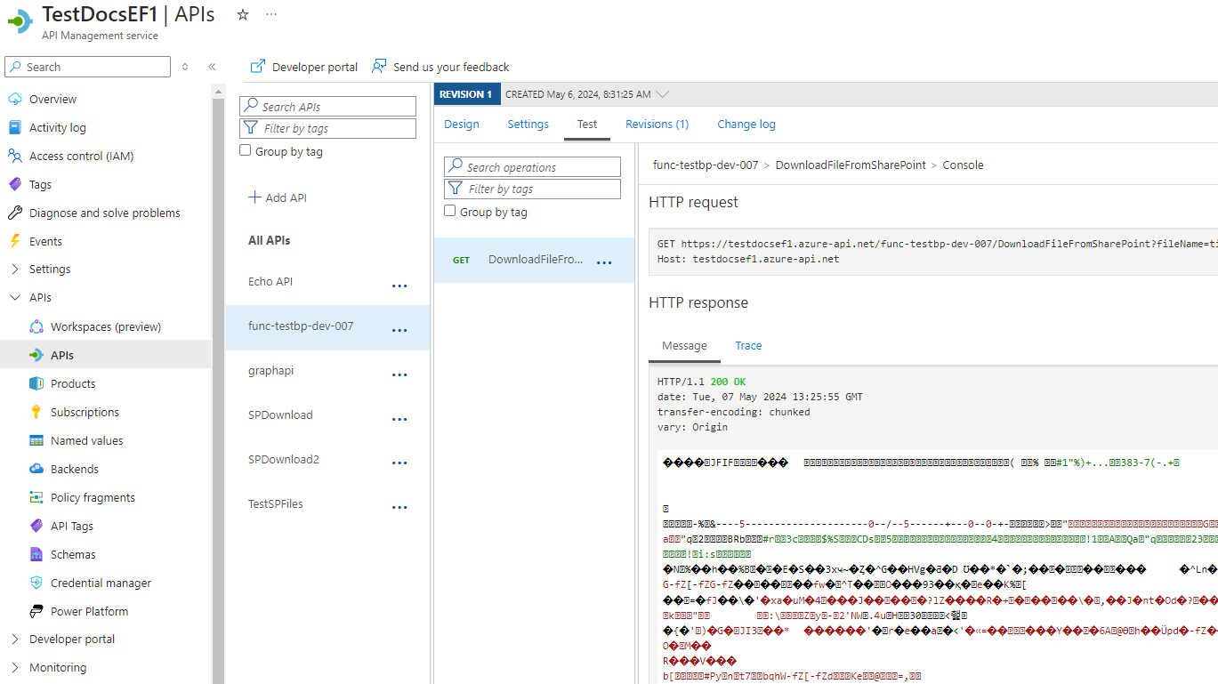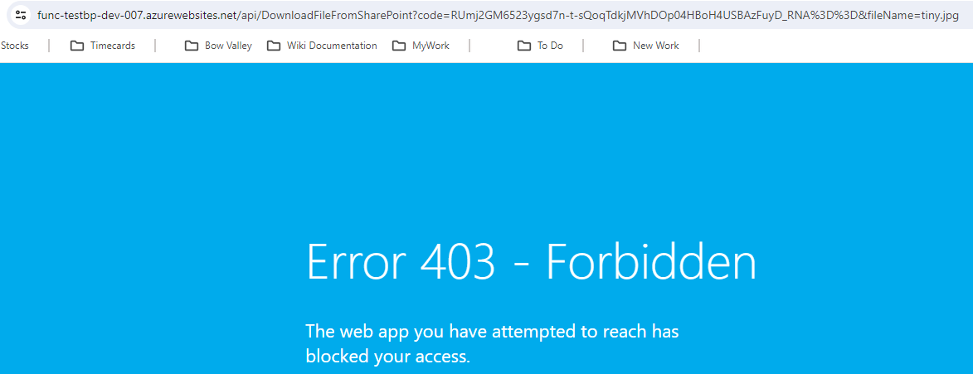

Figure

Figure

Figure

# Additional requests implemented

* 1. Replace certificate authentication with oAuth2

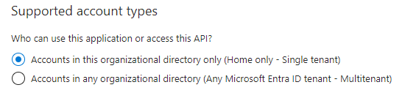8.1.1 Create an app registration for the backend APIs:

Figure 88

Figure

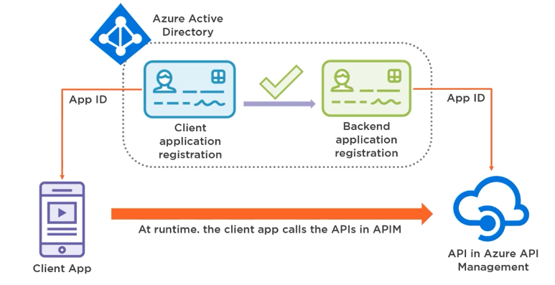

8.1.2 Expose an API and create a scope for the app registration from above:

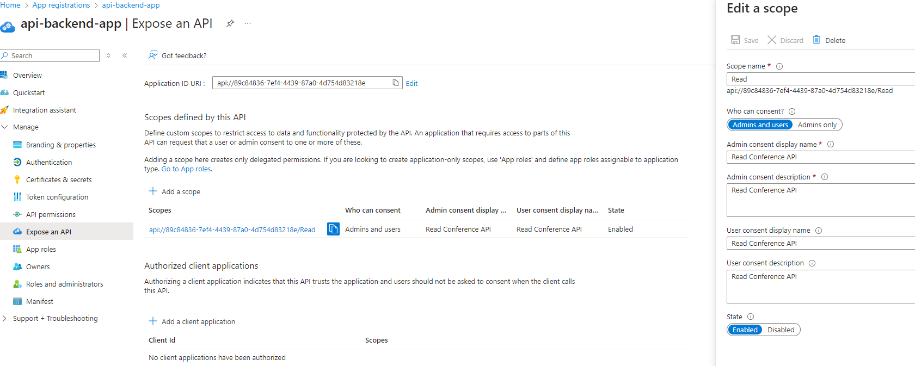 Create an Application ID URI.

Figure 89

8.1.3 Create the client application app registration

Create client credential and secret.

Add API permission and select the API from the backend app registration.

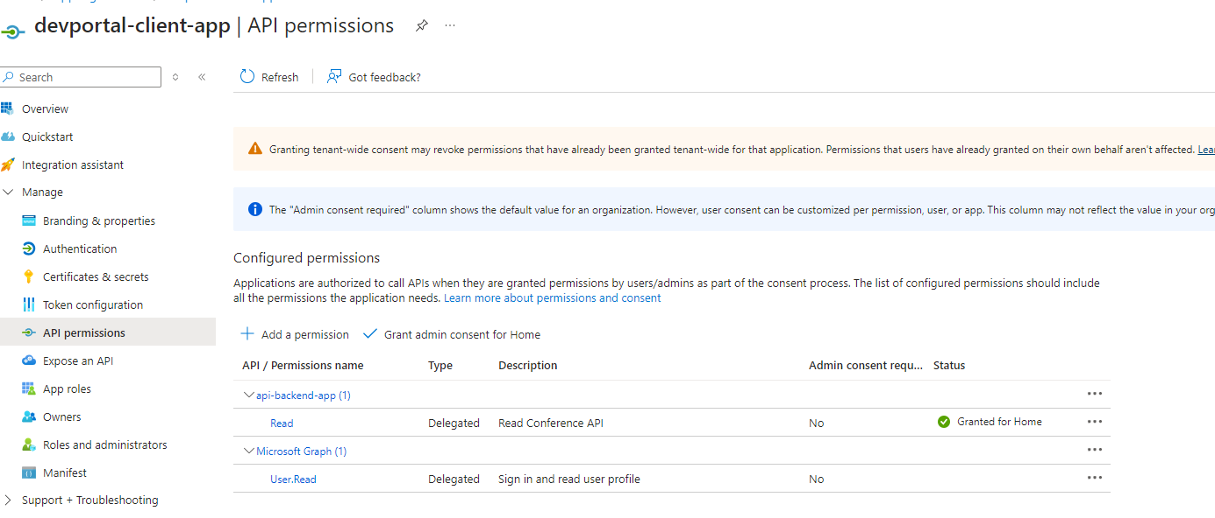

Figure 90

8.1.4 Configure API Management now

Add oAuth2 service named: Auth20service01

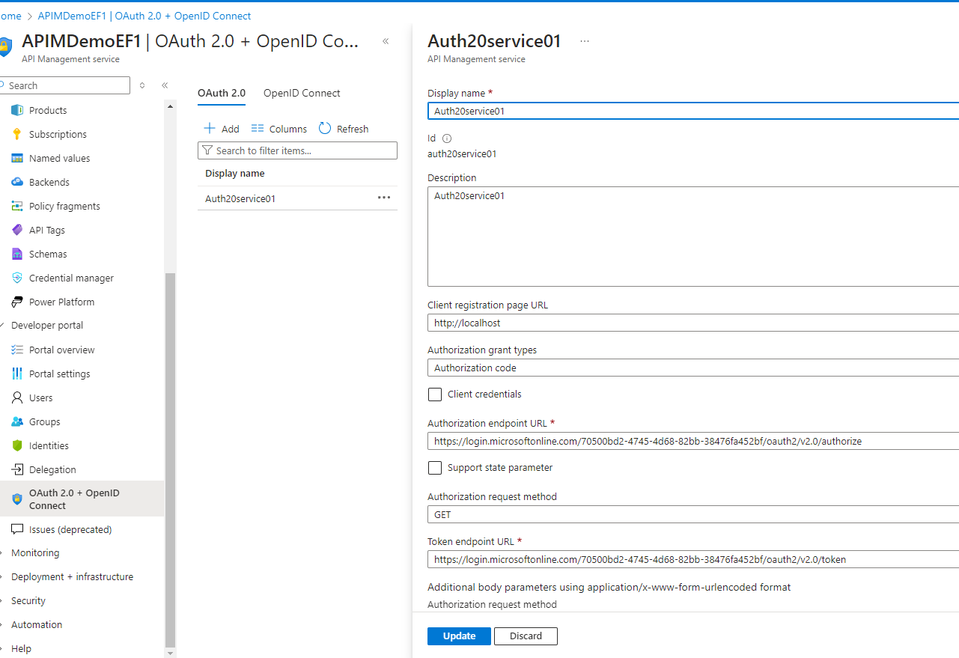Add the authorization and token endpoint from the Azure AD endpoints.

Figure 91

Add the API scope and the client credentials for the client app registration.

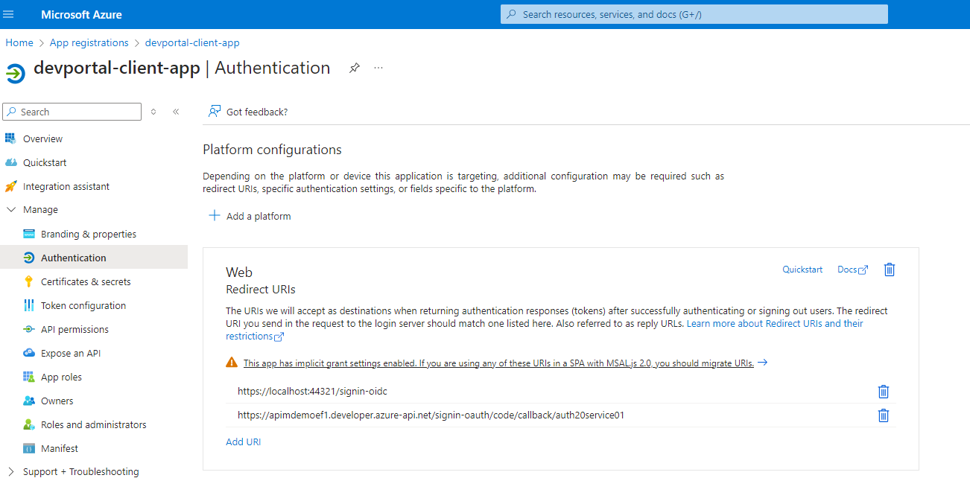Make a note for the redirect URI, authorization grant flow and update the redirect URI on the client app registration.

Figure 91

8.1.5 Now, let’s protect the API from APIM by setting up the APIM service

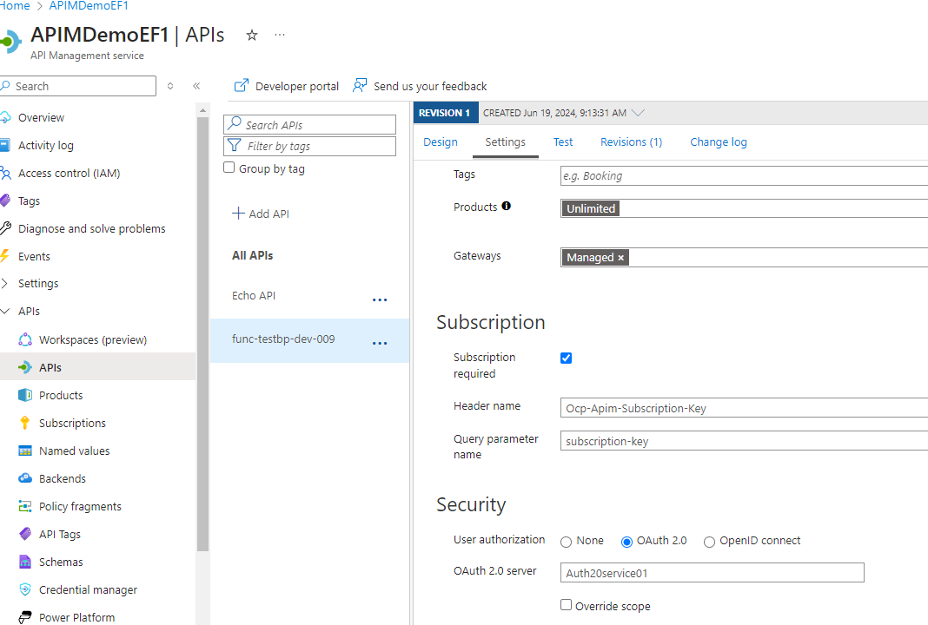Open an Incognito window in the browser and navigate to address: <https://apimdemoef1.developer.azure-api.net/>

Figure 92

Click on the APIs and on your desired API: GetUsers.

Click on the “Try It” button:

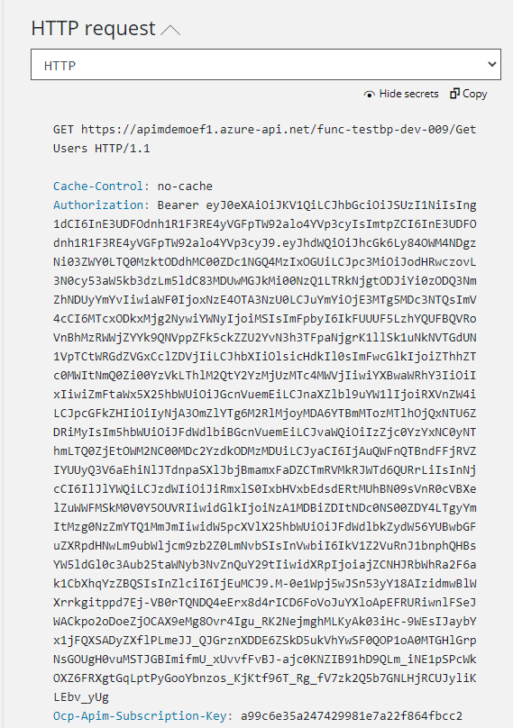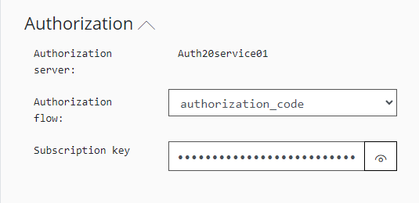

Figure 94

Figure 93

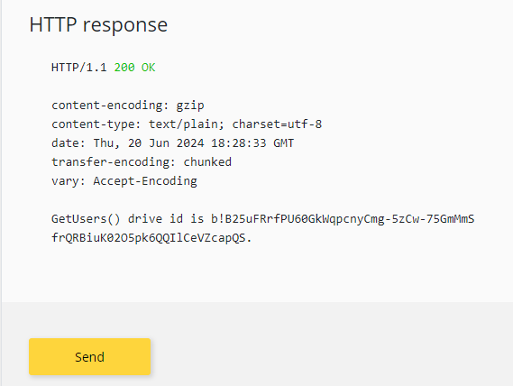You can use this token and make the same API call from Postman as well.

Figure 95

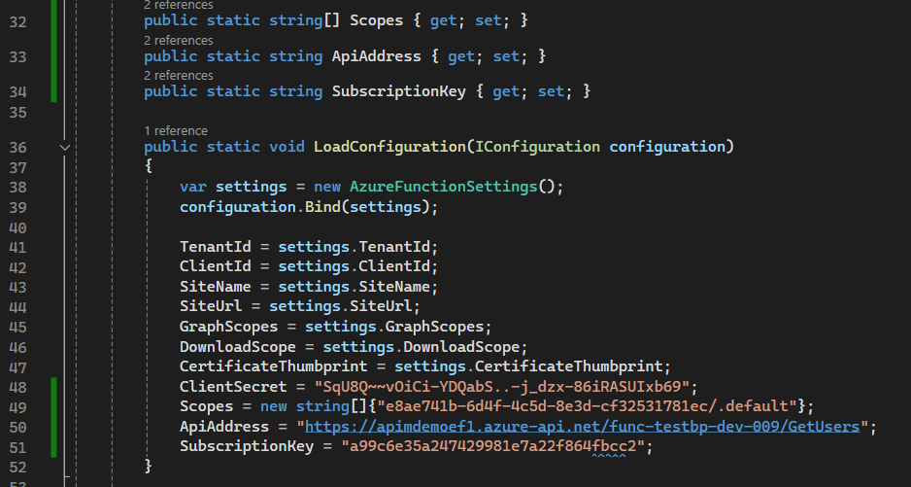8.1.6 Call the API Management API from the client app.

Figure 96

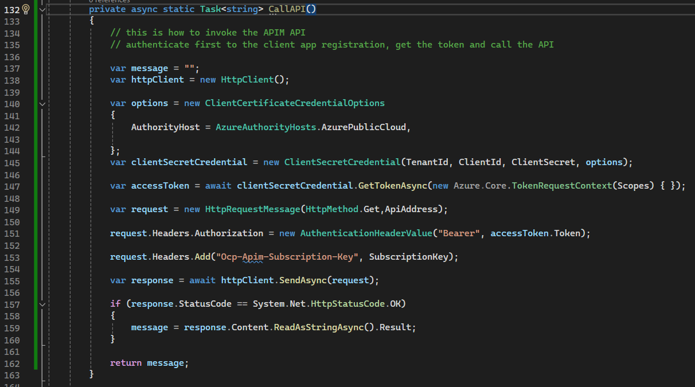

Figure 97

Note that the token contains the scope for the exposed API, see below:

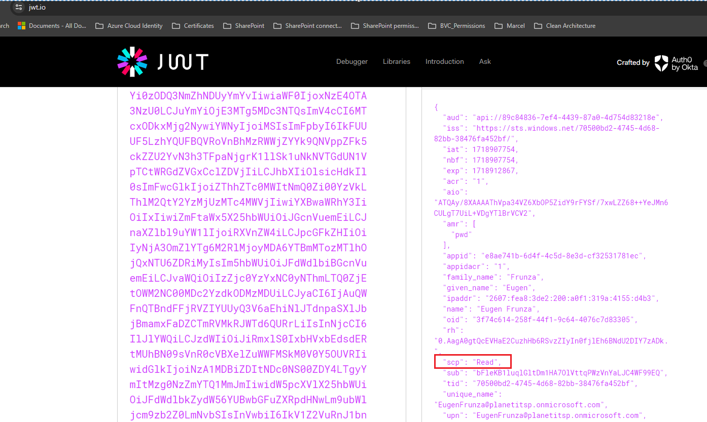

Figure 98

* 1. Add Managed Identity for the Function App

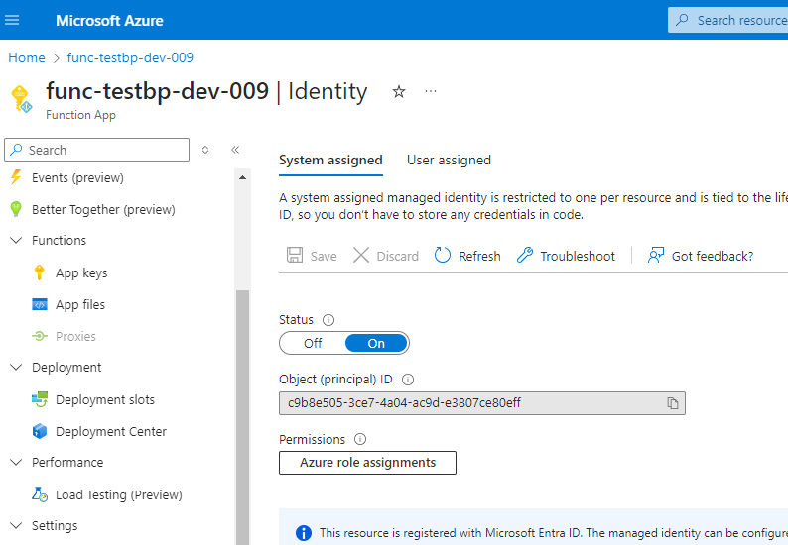Create system-assigned managed identity for the Azure function:

Figure 99

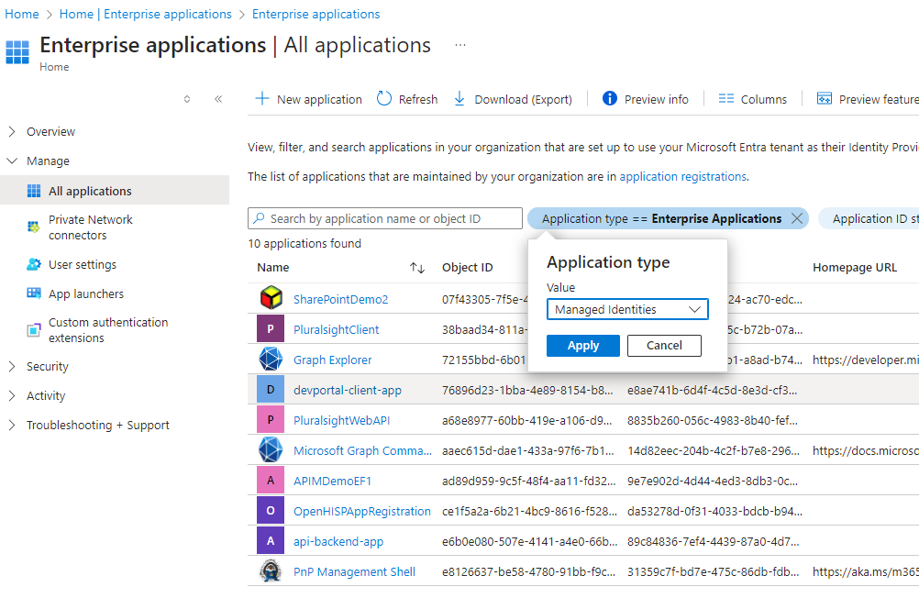Select the Managed Identity Enterprise Applications and assign the “Sites.Selected” permission via a PowerShell script:

Figure 100

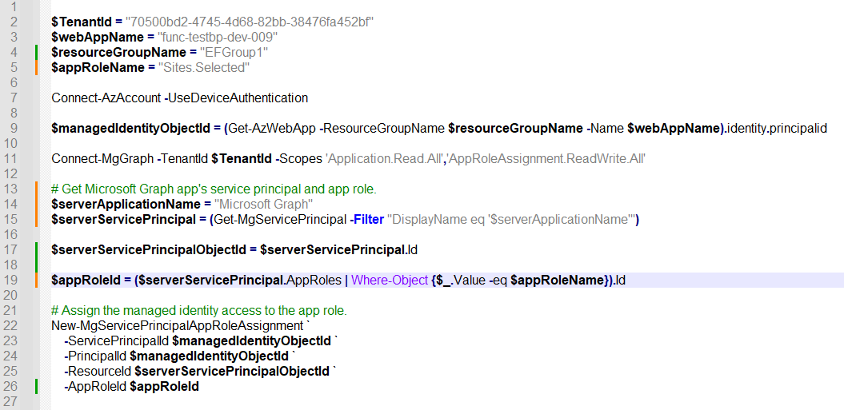

Figure 101

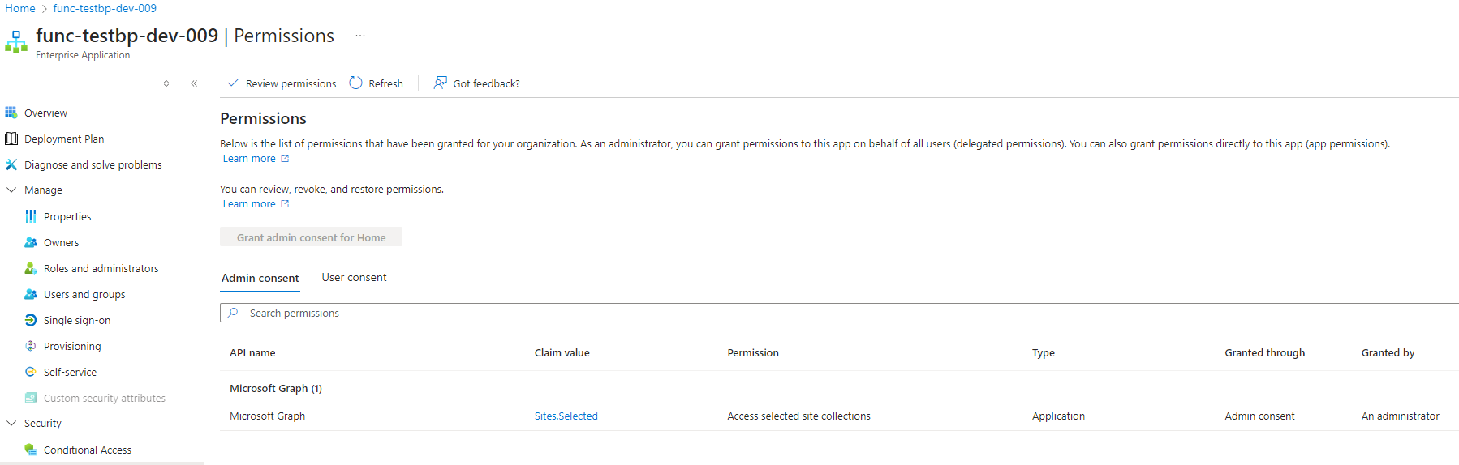

Figure 102

Inside the Function App’s code, create the GraphServiceClient like below:

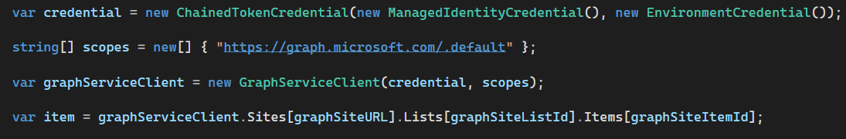

Figure 103

A good idea is to retrieve the token and parse it using JWT.IO web site:

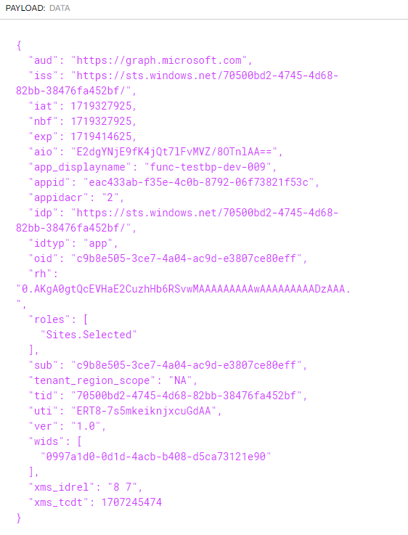

Figure 104

The same granular permission can be given by an ADMIN app registration to the function’s app registration for a site:

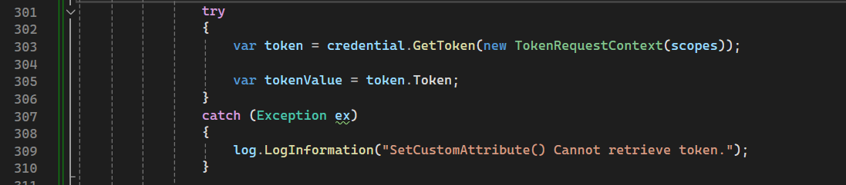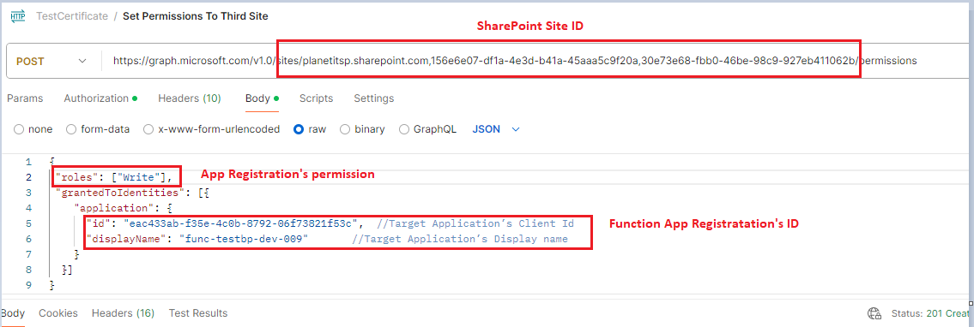

Figure 106

Figure 105

Note: After applying the permissions via the PowerShell scripts, you may need to refresh the token for all the users assigned to the application:

Connect-MgGraph

# Get Service Principal using objectId

$sp = Get-MgServicePrincipal -ServicePrincipalId c9b8e505-3ce7-4a04-ac9d-e3807ce80eff

# Get MS Graph App role assignments using objectId of the Service Principal

$assignments = Get-MgServicePrincipalAppRoleAssignedTo -ServicePrincipalId $sp.Id -All | Where-Object {$_.PrincipalType -eq "User"}

# Revoke refresh token for all users assigned to the application

$assignments | ForEach-Object {

Invoke-MgInvalidateUserRefreshToken -UserId $_.PrincipalId

}

# Approvals

**Approvers**

|  |  |
| --- | --- |
| Name | Title |
|  |  |
|  |  |